

Student Handbook

Milo Adventist Academy / 2023-25

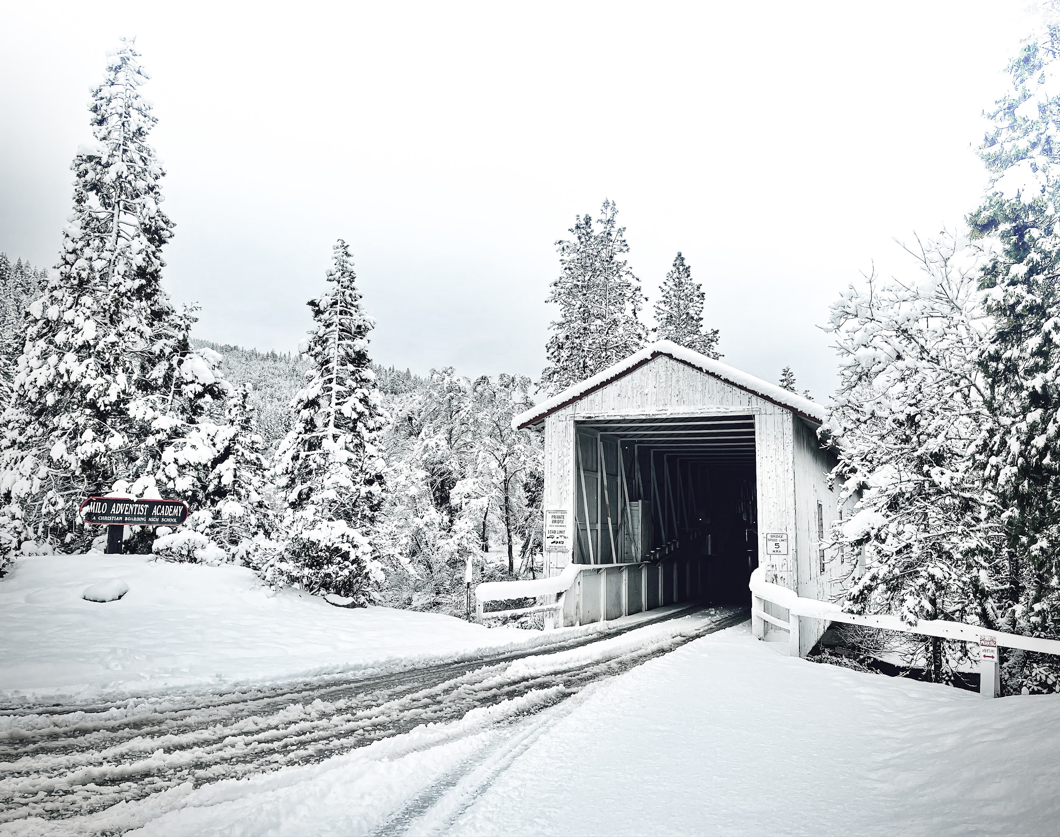

The key purpose of this handbook is to document school policies. It also serves as a guide to student life, providing orientation for both new and current students. It helps establish a tone and culture for the school.

An acknowledgement form is to be signed by the student and his or her parent or guardian to make sure that Milo’s policies and procedures have been read and understood.

This handbook is effective for school years 2023-24 and 2024-2025.

This document is subject to revision, change, or elimination as needed throughout the year without notice. The most updated version of this handbook will be posted on the school website.

Published by Milo Adventist Academy in May 2023.

324 Milo Dr.
Days Creek, OR 97429
(541) 825-3200
info@miloacademy.org
www.miloacademy.org

Cover Photo and Designer: Sergio Bellino
Campus Map Designer: Kseniia Bezkrovna (Class of ‘24)

Table of Contents

About Us 4
Our Philosophy, Our Mission, Our Vision, Our Motto, Our Core Values, Our Collective Statements of Commitment, Desired Outcomes
General Information 6
School History, Operated For, Operated By, Accredited By, Authority, Non-Discrimination, Inclusivity Statement,Incident Reporting, Communication with Teachers, Asbestos, Personal Property, Inappropriate Substances, Custodial Guardianship
Guest Information 8
Dorm Guest Rooms, Guest Houses, RVs, Hotels, Cafeteria, Direction to Campus, Contact Information
Applying to Milo 9
Arriving on Campus 9
Moving into the Dormitory, Registration, International Travel Arrangements
Campus Map 10
Spiritual Experience 11
Personal Devotions, Bible Study, Worship Services, Sabbath.
Physical Health Development 12
Rest, Food & Nutrition, Exercise, Recreational Period, Walks, Varsity Program, Medical, Horse Rides.
Social Health Development 14
Social Relationships, Social Guidelines, Social Discipline, Social Definitions, Behavioral Contracts, Discipline for Handicapped Students, Freedom of Expression, Sexual Harassment, Infractions.
Emotional Health Development 19
Dorm Discussions, Campus Ministries, Chapel, Counseling Sessions, Mentorship.
Intellectual Development 20
Graduation Requirements, Student Records, Minimum Class Load, Class Placement, Enriched Diploma, Testing, Course Offerings, Adding/Dropping Classes, Course Descriptions, Correspondence Courses, Outside Credit, Grading, Academic Standing, Tutors, D,F&I Eligibility, Graduation, Academic Recognition, Check-out Times.
Attendance Policy 24
Policy, Prearranged Absences, School-excused Absences
Practical Skills Development 26
On-the-Job Instruction, Classroom Instruction, Certificates, Dress Code & Appearance
Gifts Development 28
Leadership, Community Outreach, Mission Trips, Campus Organizations, Student Association, Senate, Music Groups, Clubs, Trillium, Milo Forum, Class Organizations.
Campus Policies 30
Safety, Home Leaves, Overnight Leaves, Off-Campus Dates, Visitor Policy, Search and Seizure, Trip and Tour, Accidents, Village Students, Vehicle, Dress Code, Computers and Network, Games.
Dorm Policies 34
Dorm Registration, Room Assignments, Room Changes, Check-out Form, Keys, Confiscations and Fines, What Not to Bring, Computers, Mail, Telephones, Voicemail Instructions, Security Cameras, Citizenship Tiers, Study Hall, Entering and Exiting the Dorm, Campus Leaves, Appliances, Dean on Duty, Fire Alarm and Drills, Fire Safety, Other Safety Regulations, Selling and Soliciting, Windows, Pets, Overnight Visitors, Time Management.
Financial Information 36
Annual Financial Supplement, Payments, Entrance Fee, Cash Items, Other Fees, Student Bank, Ways to Pay, Discount Plans, Student Labor, Financial Assistance.
Index 39

About Us

Our Philosophy (what we believe)

As Seventh-day Adventists, we recognize God as the ultimate source of existence, truth, and power. In the beginning God created in His image a perfect humanity, a perfection later marred by sin. Education in its broadest sense is a means of returning human beings to their original relationships with God. The distinctive characteristics of our Adventist worldview, built around creation, the fall, redemption, and re-creation, are derived from the Bible and the inspired writings of Ellen G. White.

We believe that the aim of true education is to restore human beings into the image of God as revealed by the life of Jesus Christ. Only through the guidance of the Holy Spirit can this be accomplished. An education of this kind imparts far more than academic knowledge. It fosters a balanced development of the whole person– spiritual, physical, intellectual, and social-emotional– a process that spans a lifetime. Working together, homes, schools, and churches cooperate with divine agencies to prepare learners to be good citizens in this world and for eternity.

Our Mission (what we have come to accomplish and how)

Milo Adventist Academy is a boarding school family committed to leading young people into a saving relationship with Jesus Christ and to growing their characters by developing their:
- Physical, social, and emotional health,
- Minds from a Christian worldview,
- Practical skills for the world of work, and
- Gifts for social responsibility

– in a safe, nurturing, and friendly environment.

Relationship with Christ
1. Health
2. Mind
3. Skills
4. Service
Environment

Our Vision (what we must become to fulfill our mission)

Joyfully serving God and others now and for eternity.

Our Motto (what encapsulates our ideals)

Character for the Kingdom.

Our Core Values (what our duties look like to each other)

Wisdom
The capacity of the mind that allows us to understand life from God's perspective.
Prov 4:5

Reliability
Something that is trustworthy and consistently good in its quality.
Isa 25:1

Adaptability
Being prepared to accept and respond to change. Scripture instructs us to be transformed into the likeness and image of Christ.
Rom 12:2

Relationship
We learn to impact others through life transformation, developing authentic relationships, and loving those we lead and serve.
Gal 5:3

Competence
We learn abilities to do something successful based on skills and knowledge after defining who we are from God's perspective.
Psalm 78:72

Passion for the Mission
Our passion comes from God's calling. It is the motivation that drives us to continue to lead young people into a saving relationship with Jesus Christ.
Isaiah 6:1-13



Milo has already completed its mission for me.

I have felt nothing but love from all

the staff and students here.

I appreciate the effort and time the staff and teachers make to help the students.

Both mentally and physically.

You are awesome Milo!

CURRENT STUDENT (CLASS OF ‘25)

Our Collective Commitments (staff)

Wisdom
We will exemplify Christ's character in our actions and by upholding school policy. We will constantly seek ways to keep our methods effective by incorporating biblical principles. We will maintain our integrity by cultivating self-awareness, hearing others' ideas, and adopting best practices.

Reliability
We will build trust by demonstrating consistent behavior until it is predictable. We will stick to principles in both easy and difficult times, remaining loyal and steadfast no matter what.

Adaptability
We will handle unexpected situations patiently, assume the best in others, be open to learn from a variety of cultures with a serving attitude, and be flexible to accommodate others’ needs. We will be tactful, reasonable, understanding, and non-judgmental.

Relationship
We will prioritize our relationship with God, understanding that it is essential to all other success. We will intentionally focus on building positive relationships, creating an environment which encourages the growth of Christ-like character. We will seek to understand the viewpoints of others, resolve conflict when it occurs, and be honest and caring. We will communicate professionally and consistently with each other, students, families, and friends.

Competence
We will model commitment to learning and growth through personal and professional development. We will create an environment that is Christ-centered, challenging, relevant, and supportive of students’ needs. We commit to ongoing assessment, accountability, and improvement.

Passion for the Mission
We will demonstrate Christ-like kindness, understanding, integrity, and respect toward each other and our students. We will strive to instill these qualities in our students, caringly holding them to high standards and behavioral excellence. We will diligently guide them away from influences that would weaken their ability to discern good from evil or lessen their interest in spiritual things and toward a saving relationship with Jesus Christ.

Statements of Commitment (students)
- I have committed my life to Christ or am willing to consider doing so.
- I am willing to learn and practice living a Christian lifestyle while enrolled at MAA.
- I welcome the idea of a campus where I will be nurtured physically, socially, emotionally, academically, and spiritually. I will contribute to the creation of such an atmosphere on the MAA campus.
- I am willing to commit myself to the process of achieving the desired outcomes in my own life.
- I will not engage in any behaviors that harm myself or others physically, socially, emotionally, or spiritually.
- I will live by the policies outlined in the student handbook.

Desired Outcomes
Students at MAA will learn, both intellectually and experientially:

Acceptance of God and His Word
Surrender one’s whole life to God through conversion; use the Bible as a basis for a relationship with Jesus Christ and a guide in all areas of life.

Commitment to the Church
Desire to know, live out, and share the basic principles of the Seventh-day Adentist Church.

Family and Interpersonal Relationships
Develop a sense of self-worth, along with skills in interpersonal relationships needed for meeting the responsibilities of family membership, and respond with sensitivity to the needs of others.

Responsible Citizenship
Develop an understanding of multicultural diversity and historical heritage, and a working knowledge of governmental processes, while affirming a belief in the dignity and worth of others and a responsibility for one’s local, national, and global environments.

Healthy Balanced Living
Accept personal responsibility for achieving and maintaining optimal physical, emotional, social, and spiritual health.

Intellectual Development
Adopt a systematic, logical approach to decision-making and problem-solving based on a body of scientific, mathematical, and historical knowledge, within the context of a biblical perspective.

Communication Skills
Acquire optimum competency in verbal and nonverbal communication, in the use of information technology, and in effective communication of one’s faith.

Life Skills
Function responsibly in the everyday world, using Christian principles of stewardship, economy, and personal management.

Aesthetic Appreciation
Develop an appreciation of the beautiful, both in God’s creation and in human expression, while nurturing individual ability in the fine arts.

Career and Service
Develop a strong work ethic and an appreciation of the dignity of service, along with an awareness of career options and opportunities, as they relate to one’s personal involvement in the mission of the church.

General Information

School History by Kristopher C. Erskine, 2020
During the years following World War II the Seventh-day Adventist membership in the North Pacific Union saw significant growth, jumping from 26,682 in 1945 to approximately 31,113 members by 1951, an increase disproportionate to the overall population growth of those living within the North Pacific Union. Both schools and churches were filled to capacity.

One of the components of the North Pacific Union was the Oregon Conference of Seventh-day Adventists. The Oregon Conference already supported Laurelwood Academy in Gaston. Although located in the state of Washington, Columbia Adventist Academy also attracted some Oregon students due to its location just north of Portland. Enrollment at Laurelwood Academy in 1951 was 421, all housed in a single dormitory.

The campaign began in earnest, and at one of the Oregon camp meetings in the early 1950s “mysterious signs [were] posted in conspicuous places” that read, “319,” catching the attention of camp meeting attendees. Before the session ended, “everyone far and near was in on the secret”--it was the estimated number of Adventist students of academy age not attending Adventist schools. For that reason “a beautiful new site was purchased in Southern Oregon, near Milo.” Donald Van Tassel, Milo’s first history teacher, reports in an unpublished manuscript on the history of the academy that a local Adventist named Walter M. Corwin sold his 447-acre Bar Lazy Eight ranch to the church for $65,000, substantially less than it was worth. Van Tassel also states that the sale included barns, a fruit drying building, a farmhouse, two tractors, two cows, one heifer, one horse, and one colt. Most of the buildings were either torn down or moved to make way for the new academy.

By the end of 1952, although no foundations yet existed for the school buildings, steady progress could be seen at the site of what would become Milo Academy. Notices in the North Pacific Union Gleaner (NPUG) advertised for “two or three, top grade, experienced” carpenters, and under the supervision of superintendent George Johnson, the construction of Milo Academy began. The conference estimated the project would cost around $250,000.

The conference scheduled the school to open the fall semester of 1955. Most of the faculty and staff were in place by the spring of that same year, and in May Milo Academy hired its first principal, L. E. Russell. Russell, who would also serve as business manager, would arrive from Ozark Academy in June.

The Iconic Bridge
The only way onto the property was across a decades-old wooden covered bridge across the South Umpqua River. After eight years of heavy Milo Academy use, however, the school determined that the wooden structure was no longer safe for its heavy farm vehicles, even after extensive repairs on the bridge. By March of 1960 a new steel trestle bridge paralleled the old wooden one. Although nothing has been found to verify the claim, several sources indicate that local residents wanted the new bridge covered. By 1962 the upper structure of the original bridge had been transferred to the new one and Milo once again had a covered bridge. The Milo Academy Bridge, listed on the National Register of Historic Places, has remained an icon to Milo graduates across the decades.

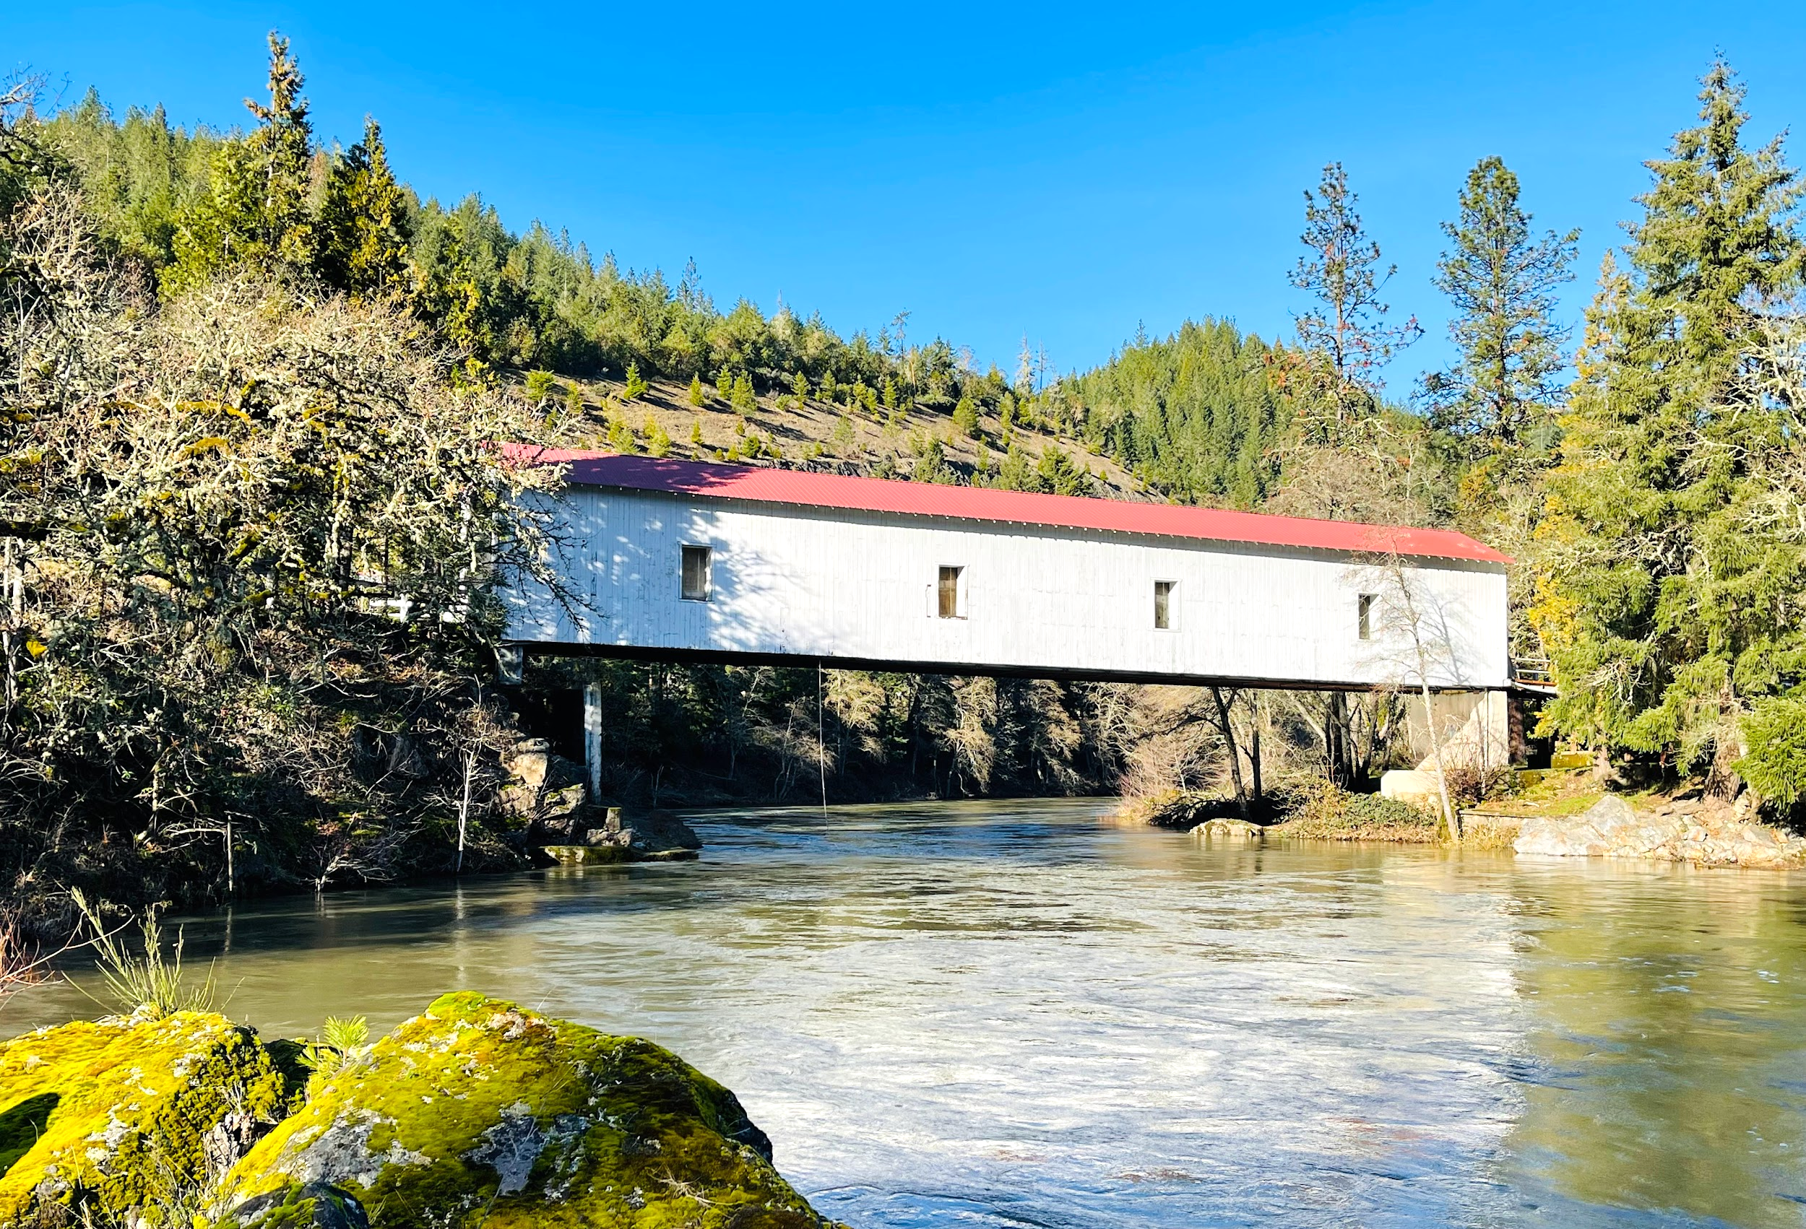

Operated for
- Young people who desire a Christian education.

Operated by
- The Oregon Conference of Seventh-day Adventists.
- The President of the Conference is the Chairman of the Board of Directors, which is authorized to operate the academy

Accredited by
- The Middle States Association-Commissions on Elementary and Secondary Schools.
- Adventist Accrediting Association.
- National Council for Private School Accreditation.

Authority
The principal, along with the administrative team and those faculty and staff hired by the administration and the Board, has been charged with the responsibility for the successful operation of the school. Students are expected to give proper respect to and show courteous behavior toward those in authority. Parents are encouraged to cooperate with and support the position of the administration, faculty, and staff.
A student is always expected to follow the direction of a staff member unless the student is being asked to do something illegal or immoral. If a student feels they are being treated unfairly, they should do what is asked and then come to the principal or to their designated representative to explain their concern. We encourage open dialogue in a kind and tactful manner as we jointly tend to the task of training and educating our youth.

Non-Discrimination
MAA admits students of any race to all the rights, privileges, programs and activities generally accorded or made available to students at the school and does not discriminate on the basis of race, color, ethnic background, country of origin, or sex in the administration of education policies, applications for admission, scholarship programs, and extracurricular programs. Milo supports the enrollment of all students that support the teachings of the Seventh-day Adventist Church.

Inclusivity Statement
MAA is committed to fostering an environment of diversity, equity, and inclusion. Our diversity makes us stronger. We desire to nurture an inclusive staff and student body. As followers of Christ, our greatest desire is to love like Jesus by recognizing the value of every person. We strive to treat all humanity with unconditional dignity, respect, and love, while celebrating our differences. We pray to live out God’s kingdom by doing all within our power to create an environment where every student experiences safety, belonging, inclusion, and love. Therefore, it is unacceptable to tolerate or propagate slurs or jokes that target others. Furthermore, we promote a culture where no one remains silent when others suffer, are victimized, or marginalized. We will not tolerate any form of racism, discrimination, bullying, harassment, hatred, or bigotry.

Incident Reporting
Parents and students are encouraged to speak with administration or a trusted staff member when they have a safety concern. If the parent or student wishes to remain anonymous, they may use the reporting form provided on the school website.

Communication with Teachers
We encourage parents to communicate directly with teachers by utilizing teacher contact information as printed in the handbook, Google Classroom, and the REMIND app. To protect teacher/student relationships, we ask that students contact their teachers only through approved applications [examples: REMIND app, Google Classroom, or school email], and not through texting on personal devices. Our school policy requires teachers to also avoid contacting students privately on any social media sites.

Asbestos

Federal law requires a public announcement to be given to school patrons regarding any asbestos material in a school. MAA has been checked by a certified asbestos person. The report is filed in the maintenance department and is available for those wishing to see it. The asbestos in MAA is in a non-friable condition and presents no hazard to anyone at the present time. It will be checked at stated periodic intervals to ascertain any change in the material.

Personal Property
Administration may search a person and/or their personal property. Searches may be conducted at any time on our property or when the student is under the supervision of a school-sponsored activity. Administration may seize any item which is suspected not to be or is not in accordance with school or state policy, or has potential to interfere with the safety of others. Such items may include lockers, backpacks, purses, cars, or any other personal belongings. The administration reserves the right to ask for electronic devices to be unlocked. Any confiscated property may be returned at the discretion of the school administration or turned over to the law enforcement as needed. Administration may perform random searches. Administration will use the right for individual search and seizure to the best of their ability when there is reasonable suspicion to believe there is evidence of a violation of school policy or state law.

Inappropriate Substances
Administration has the right to test for inappropriate substances. Students under the influence of inappropriate substances or found to be in possession of prohibited or illegal items or substances will face school disciplinary action, arrest, and/or prosecution.

Custodial Guardianship
As a school, we do our best to follow legal documentation for custodial requests. We cannot make custody accommodations for your child without appropriate court orders. If there are any custody orders or restrictions regarding your family that impact your student in this school, please inform us and provide copies of legal documentation.

Learning Disabilities
The Individuals with Disabilities Education Act (IDEA) is a federal law that requires each state to ensure that a free appropriate public education (FAPE) is available to all eligible children with disabilities residing in that state. Although students enrolled in private schools do not have the same right to special education as students in public school, IDEA does outline a pathway for dealing with private-school students with learning disabilities. The public school district where the private school is located is responsible for determining eligibility and developing the plan for special education services.
Milo Adventist Academy is ready to facilitate this process upon the parents request. For information about the IDEA and possible services follow the link below:
https://www.smartkidswithld.org/getting-help/know-your-childs-rights/private-schools-and-idea/

Sexual Harassment Policy
See page 16, under Social Health Development.
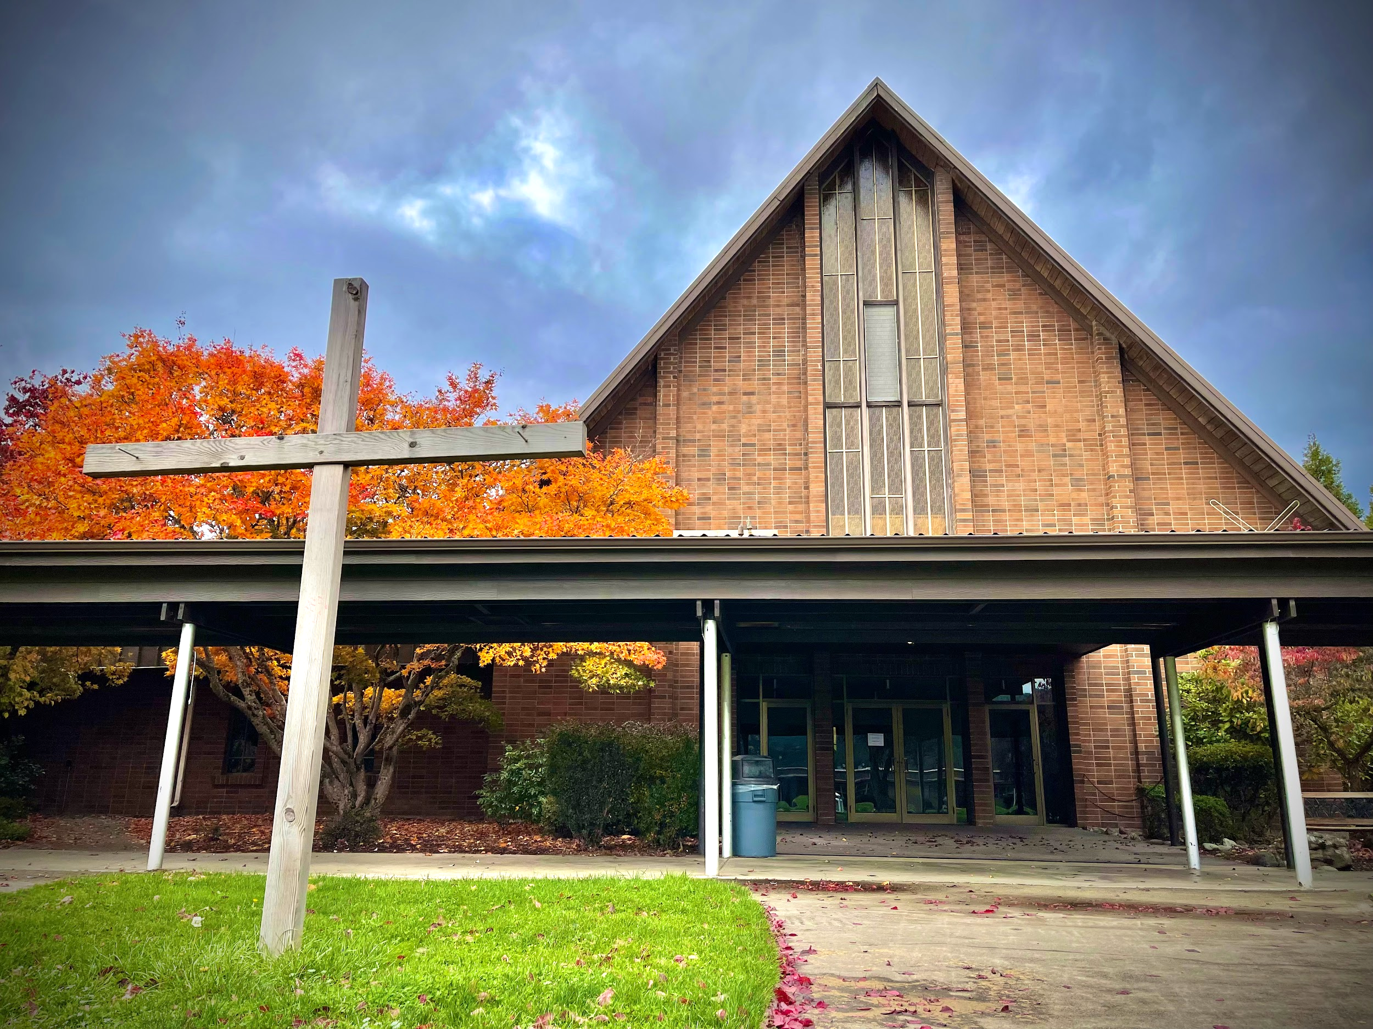

Guest Information

See the current Financial Information Supplement to the handbook for prices or check with the administrative assistant at 541-825-3200, ext. 3321.

Dorm Guest Rooms
Each dorm has a limited number of guest rooms for a nominal fee. Contact one of the deans for availability and reservations.

Guest Houses
Call 541-825-3200 to check availability or to make reservations with the administrative assistant.

RVs
Sixteen RV spots with electricity, water, and septic may be reserved by calling the administrative secretary at 541-825-3200.

Hotels
Canyonville is at exit 98 and is 18 miles from MAA. Hotels there include:
Creekside Hotel and Suites, located at exit 99
541-839-4200
Leisure Inn, 554 SW Pine
541-839-4278

Cafeteria

Weekdays
Breakfast 6:30–7:30 AM
Lunch 12:15–1:00 PM
12:00–12:40 PM Fridays
Supper 5:30–6:30 PM
5:00–5:30 PM Fridays

Sabbath
Breakfast 8:00-8:30 AM Or sack meal
Lunch 12:30 PM Or ½ hr after church
Supper 5:00–6:45 PM

Sunday
Brunch 10:00–11:00 AM
Supper 4:00–4:45 PM
Meal tickets may be purchased with cash or charge cards from the business office. You are encouraged to purchase meal tickets in advance for weekends you will be visiting MAA. Tickets are valid for the entire school year. Current prices can be found in the current Financial Information Supplement to the handbook.

Directions to Campus

From I-5 Northbound
Take Canyonville exit 98, turn right (east) at the end of the ramp, left (north) on Main Street two blocks, right (east) on 3rd street also called Tiller Trail Hwy.

From I-5 Southbound
Take Canyonville exit 98, turn left (east) at the end of the ramp, right (south) on Main Street two blocks, left (east) on 3rd street also called Tiller Trail Hwy.
Milo is 18 miles from Canyonville on the Tiller Trail Hwy. Look for the white covered bridge crossing the South Umpqua River. (Days Creek is about halfway between Milo and Canyonville.


Contact Information

541-825-3200
541-825-3723 (Fax)
info@miloacademy.org
www.miloacademy.org
Milo_Adventist_Academy
Milo Adventist Academy
Milo Adventist Academy
324 Milo Dr
Days Creek, OR 97429

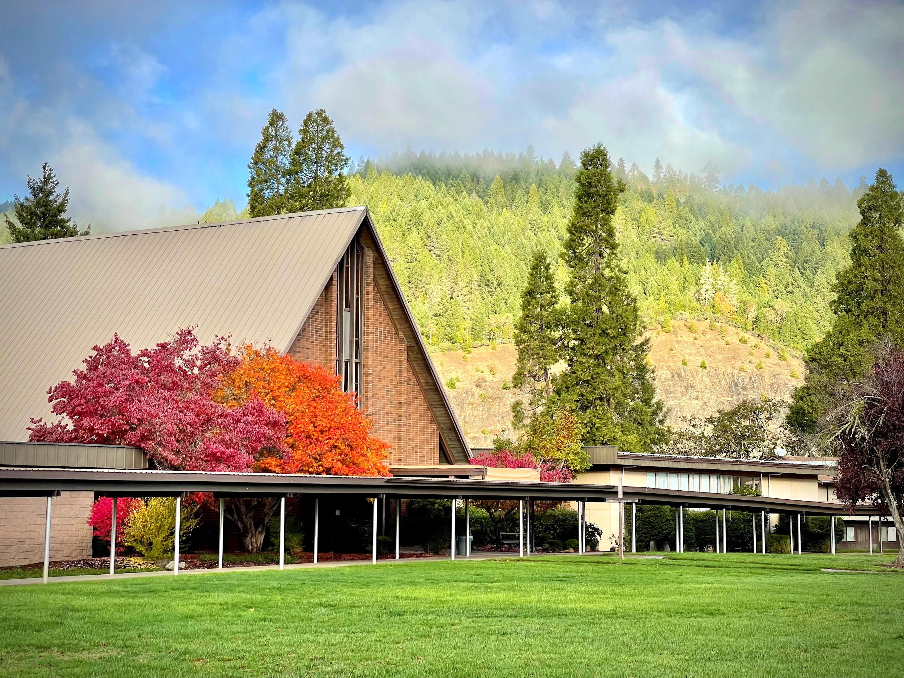

Applying to Milo

Application Procedure for New Students

All Students
- Fill out an application on our website at: https://ma-or.client.renweb.com/oa/register.cfm?memberid=1373
- Fill out the Financial Application at: https://online.factsmgt.com/signin/4C06S, to receive a Financial Plan. If you agree with the plan, sign it and return it to the Business Manager.
- When we receive 3 recommendations the process will continue.

U.S. Students Only
- Send a copy of your report card(s) for 8th, 9th, 10th, 11th grades (as pertinent to you) to admissions@miloacademy.org
- The Admissions Department will send you an invitation to your interview.
- Once the Admissions Committee has reviewed your application, you will be notified of acceptance or denial of admission via email.

International Students Only
- Send a copy of your 8th, 9th, 10th, 11th, 12th grade transcripts (as pertinent to you) to: spantran.com. Have them send the results to admissions@miloacademy.org.
- If English is not your primary language, take the iTEP SLATE English test: https://is.gd/itep_MiloAdventistAcademy.
- Send a copy of your immunizations record and the Oregon CIS form to admissions@miloacademy.org. The Oregon CIS form can be found here:
https://www.oregon.gov/oha/ph/preventionwellness/vaccinesimmunization/gettingimmunized/documents/schcisform.pdf
- You will be contacted by Admissions to schedule an interview. After the interview, the Admissions committee wJill review your application and notify you of their decision.
- If you receive an acceptance letter, you will receive an i20, which you need to get your F1 visa (We cannot issue an i20 unless we have a signed Financial Plan).
- You can now pay the I-901 Fee here: https://www.fmjfee.com/i901fee/index.html
- Be sure to fill out the DS160 here: https://ceac.state.gov/GenNIV/Default.aspx in order to make an appointment at the US Embassy near you.
- After your Embassy appointment, please let us know the outcome at admissions@miloacademy.org.
Upon acceptance into Milo Adventist Academy, international students will be issued the required I-20.

Enrollment for New & Returning Students
- Login to Renweb Family Portal: https://logins2.renweb.com/logins/parentsweb-login.aspx
- District Code: MA-OR
- Enter your username and password. If this is your first time logging in to the Family Portal, you must create a new account. Contact Admissions if you have any issues.
- Once you login, Select Apply / Enroll along the green menu on the left side of the screen, then select Enrollment / Reenrollment. Select Click here to open Enrollment.
- You will then see your student’s name and the grade for enrollment. Click on Start Enrollment Packet.
- This will open the Enrollment form. It has a red menu along the left hand side. Each menu item is a page in the Enrollment Packet. As you complete each page, a green check mark will appear on the left indicating completed or a yellow exclamation mark indicating incomplete. Once you have completed the Enrollment, select Submit.

Arriving on Campus

Moving into the Dormitory
All students move in on registration day. Room and roommate assignments are made by the deans; individual preferences and choice may be considered. Changes can be made throughout the year by consulting with the dean.

Registration
At registration the many details of work assignments, class schedules, and paperwork are processed. You will be given a checklist of tasks that need to be completed to make this process easier. Completion and return of all forms sent to you prior to Registration Day will expedite the registration process for you.

International Travel Arrangements

Before you make your plans:
- Make flight reservations to the Medford Airport (MFR).
- No transportation is provided to MAA from Portland.
- Make sure dates and times arriving to and departing from MFR correspond with the schedule. Contact info@miloacademy.org for the current schedule.
- NO transportation will be provided to or from the Medford Airport for arrivals or departures from 12:00 PM Friday afternoon through 8:00 AM Sunday, nor between 9:00 PM and 8:00 AM on weekdays.
- All students arriving at Medford Airport must not leave the airport until they are met by an official Milo representative. If a Milo representative is delayed by traffic conditions or other unforeseen circumstances, the student/passenger is to remain at the airport and call 541-825-3200, Ext. 3321 for further instructions.
- If family members are accompanying students to or from MAA, arrangements need to be made in advance for additional transportation, lodging, and meals. Additional charges may apply.

After you make your plans:
- E-mail your complete airline itinerary to info@miloacademy.org.

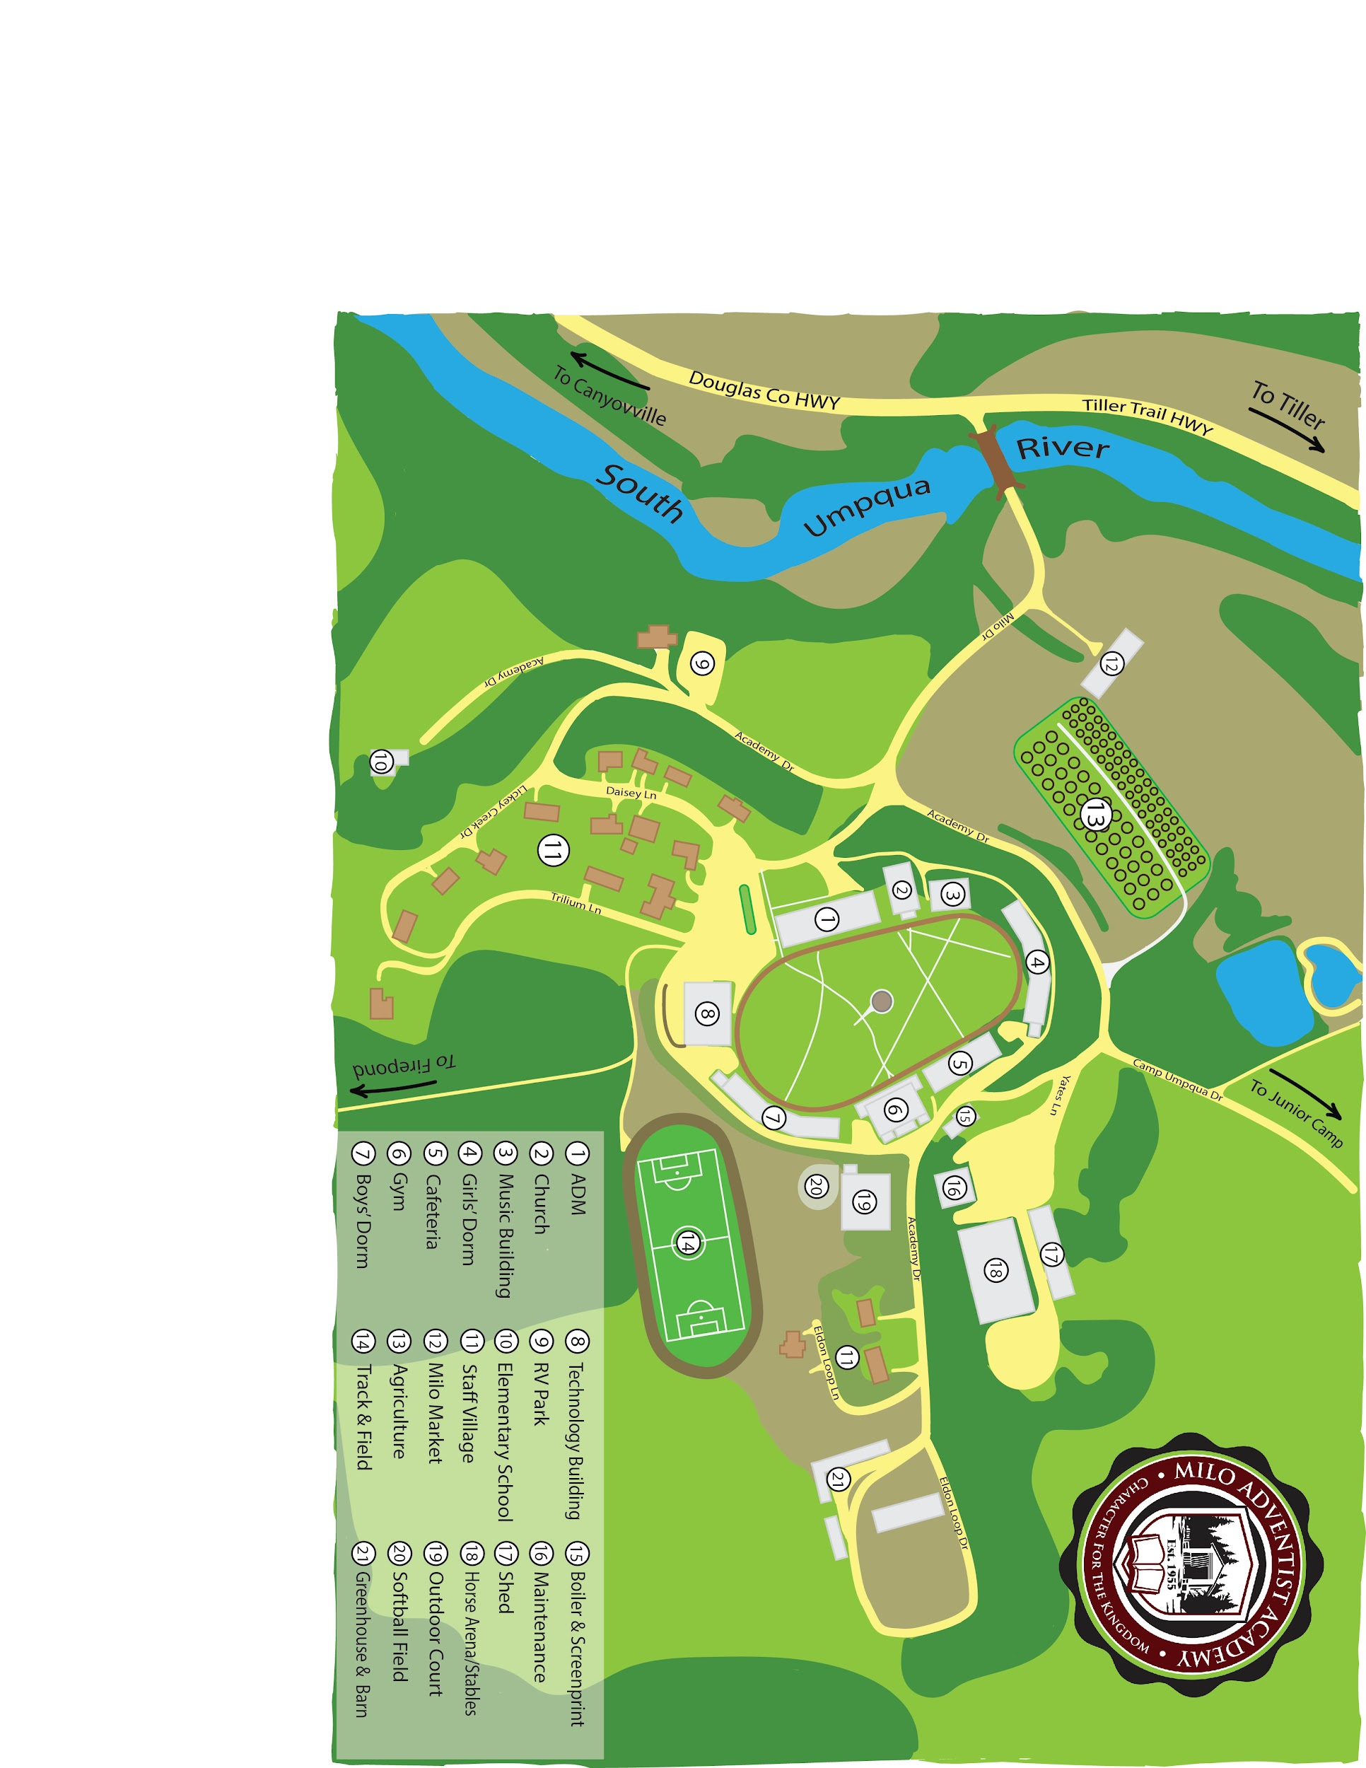
Campus Map

Spiritual Experience

MAA is committed to providing an atmosphere and learning experiences that will enable students to achieve the spiritual excellence of which they are capable.

Goals
That each student will be encouraged to:
- Want to begin and/or maintain a friendship with Christ.
- Grow in ability to reflect the qualities of God’s character: love for others, kindness, unselfishness, patience, and tolerance.
- Recognize and use their God-given talents for the purpose of helping others.
- Establish spiritual habits for success in all endeavors.
- Understand, by personal experience, salvation by faith.
- Grow in their knowledge of God.
- Deepen their understanding of Scripture

Tools for achieving these goals include
- Personal devotions
- Group and/or one-on-one Bible studies
- Worship services
- Bible classes
- Mentoring and discipling by committed Christian faculty, staff, community members, and student leaders.
- Providing a rural setting in which an atmosphere conducive to quiet time with God may be more readily established
- Planned opportunities for student ministry to others, including leadership in worship services and other meetings, community outreach, mission trips, etc.
- An atmosphere conducive to worship and spiritual growth.

MAA is a Seventh-day Adventist Christian school. Every activity is planned to enhance spiritual growth. Being a Christian is accepting a lifestyle committed to continual growth in Christ.

Personal Devotions
Just as it is impossible to grow physically without a balanced diet, so it is with spiritual growth. You cannot have someone else eat your food for you and expect to live. Neither can you live very long without breathing. Reading from the Bible or a devotional book is spiritual food for the soul and mind. Prayer is the breath to spiritual life.

When we realize the necessity of spending some time each day with God on a one-on-one basis, we will make it our highest priority. Students may think the daily schedule at Milo is so full that it doesn’t allow time for personal devotions. Life in the adult world will be equally as busy. The secret is to develop the habit of making time to spend with God. Spiritual growth cannot be attained without it.

Bible Study
God has put us into each other’s lives. As part of the family of God, we are called to support one other in furthering our knowledge of, and experience with, Jesus. To help with this, group and one-one-one bible study opportunities are offered through our pastor, Campus Ministries team, staff members, and student leaders. Topics are tailored to different groups and/or individuals, so there are multiple opportunities to learn many awesome truths about our God throughout the year.

Additionally, Bible study materials and devotions for personal use are available for anyone through Campus Ministries on a number of different topics to help provide a structured study during times of your choosing.

Worship Services
Worship services at MAA are designed to be a time of praise, worship, and inspiration. Services include dormitory worship, mid-week prayer meetings (ReCharge), Friday vespers, Sabbath School, church services, and additional meetings on Sabbath, as well as special weeks of spiritual emphasis.

Worship is meant to be active. To enhance our personal experience, we actively participate during our worship times together. We actively listen to the speakers who have words of inspiration to share. We sing praises to our God. We participate in group activities and engage in small group conversations. We use our God-given gifts to help others worship our Lord and Savior.

To avoid distractions during our times of spiritual focus, the student should enter quietly and remain inside until dismissed. Take care of personal needs before the service so that you will not need to leave your seat during the meeting. Students sitting together should sit up without leaning against each other and placing their feet on the pew in front of them.

Village students are required to attend and participate in worship services when on campus.

Sabbath
The gift of the Sabbath carries a very special meaning for those who have experienced the blessings it brings. Enabling an atmosphere that enhances the Sabbath experience is an important goal at Milo.

We welcome the Sabbath hours with a vespers worship on Friday evening and close them with Sunset Meditations at sundown on Saturday evening. All dormitory residents are expected to join in these times of worship.

During these special hours, we put aside all secular activities and devote our energies to developing strong and healthy relationships with God and with the people around us.

We do this by attending the services, and on a voluntary basis, participating in Sabbath afternoon activities. These may include a nature hike, informal singing, Bible games, outreach in the community, discussion groups, etc. Village students are invited and encouraged to be a part of Sabbath activities on campus.

We are grateful for Milo being a school where the name of Jesus is made popular.

A PARENT

Physical Health Development

MAA is committed to providing an atmosphere and learning experiences that will enable each student to achieve the physical excellence of which they are capable.

Goals
- To learn to value physical fitness and healthy living.
- To learn how to effectively manage time and activities for optimal outcomes for all aspects of health.
- To learn to eat at mealtimes and gain experience in selecting a healthy diet.
- To establish self-discipline and sleeping habits that will promote wellness.
- To maintain habits of personal hygiene and grooming that will enhance a healthy lifestyle and an effective Christian witness.

Rest
Adequate rest is essential for physical, mental, and spiritual development, especially in the teen years. Most students at Milo have very busy schedules. In order to receive adequate rest, they must become skilled in self-discipline and time management.
Deans set, maintain, and enforce bedtimes to help facilitate adequate sleep for all dorm students, however, students who are not getting sufficient sleep are encouraged to counsel with a dean or staff member who can help them find ways to use their time wisely to achieve all their goals.

Food & Nutrition
Milo provides a well-organized food service program in harmony with the principles of the Seventh-day Adventist Church. Because of our regard for health, we do not serve meat or beverages containing caffeine, and we provide low-fat foods as feasible.

To accommodate individual tastes, a salad bar is available at most meals in addition to the entrees and vegetables at the deck. Students with special dietary needs are invited to communicate with cafeteria personnel to design a plan to meet those needs.

Exercise
Opportunities are available at Milo for obtaining regular exercise. Our rural environment provides a beautiful and peaceful setting for jogging, walking, hiking, and bicycle riding. Swimming is allowed with proper supervision and a certified lifeguard present.

A daily recreation period is built into the schedule. During this time students are encouraged to join in the organized intramural games, or they may walk or jog in one of the designated campus areas.

Recreation Period
Sunday 1:00 - 4:00 & 6:20 - 7:20 PM
Monday - Thursday 6:20 - 7:20 PM
There are to be no student activities in the gym or other PE facilities without direct faculty supervision. The school cannot assume responsibility for students unless their activity is under the direct supervision of an authorized adult.

During recreation period students may be at an assigned recreation location, in their respective dorms, in their defined walk direction, or in the student center when it is open.

Walks

Usual walk areas
Odd Days Even Days
Boys mountains river
Girls river mountains

Mountain: through the pasture beyond the track and up into the mountains, students must seek permission before hiking to “Craig’s Lookout.”
River: includes the roads to junior camp and the elementary school, and from those roads down to the river.

Walk areas during hunting season
Odd Days Even Days
Boys down-river up-river
Girls up-river down-river

Up-river: The road to junior camp.
Down-river: From the bridge and down-river.

Varsity Program

Purpose
Students who would like to be involved in friendly competition may try out for one of the inter-school varsity teams.
The purpose of the varsity program is to enable students to:
- develop teamwork and cooperation skills.
- learn to accept both victory and defeat with a gracious Christian spirit.
- experience the satisfaction of reaching out to students of other schools with a lifestyle witness.

Participation in Varsity Sports
Participation in the varsity program includes playing as a member of a varsity team, a junior varsity team, or any other team which competes with a team of players from another school, or assisting with a game in any capacity (e.g. as scorekeeper).

Students who wish to participate in varsity must pay a fee in advance at the business office for each sport in which they are involved. This fee helps to cover some of the extra costs of the varsity program. Fees are $150.00 for the first sport, $125.00 for the second sport, and $100.00 for the third sport played.

Students who are not in the varsity program, but who wish to attend off-campus games must ride in school-provided transportation, and they must meet the same eligibility requirements as students who participate in the varsity program.

Eligibility
Students in a varsity program are in a position to witness by lifestyle and must maintain a high standard of excellence. They will be expected to display the highest sportsmanlike conduct.

Academic Eligibility
- A GPA of 2.5 or higher for the most recent quarter.
- Having no current grade of F in any class, and no more than one class with a grade of D (DFI list).
- Grade changes that affect eligibility must occur the week prior to any games that the student may participate in. Ineligibility affects the entire week.

Citizenship Eligibility
- Appropriate citizenship grade.

Attendance Eligibility
- Maintain at least a C in attendance.
- Having been present at work and in every class on the day of the game, unless prearranged.
- If a student misses classes or work the day following a game, he or she will be ineligible for the next game.

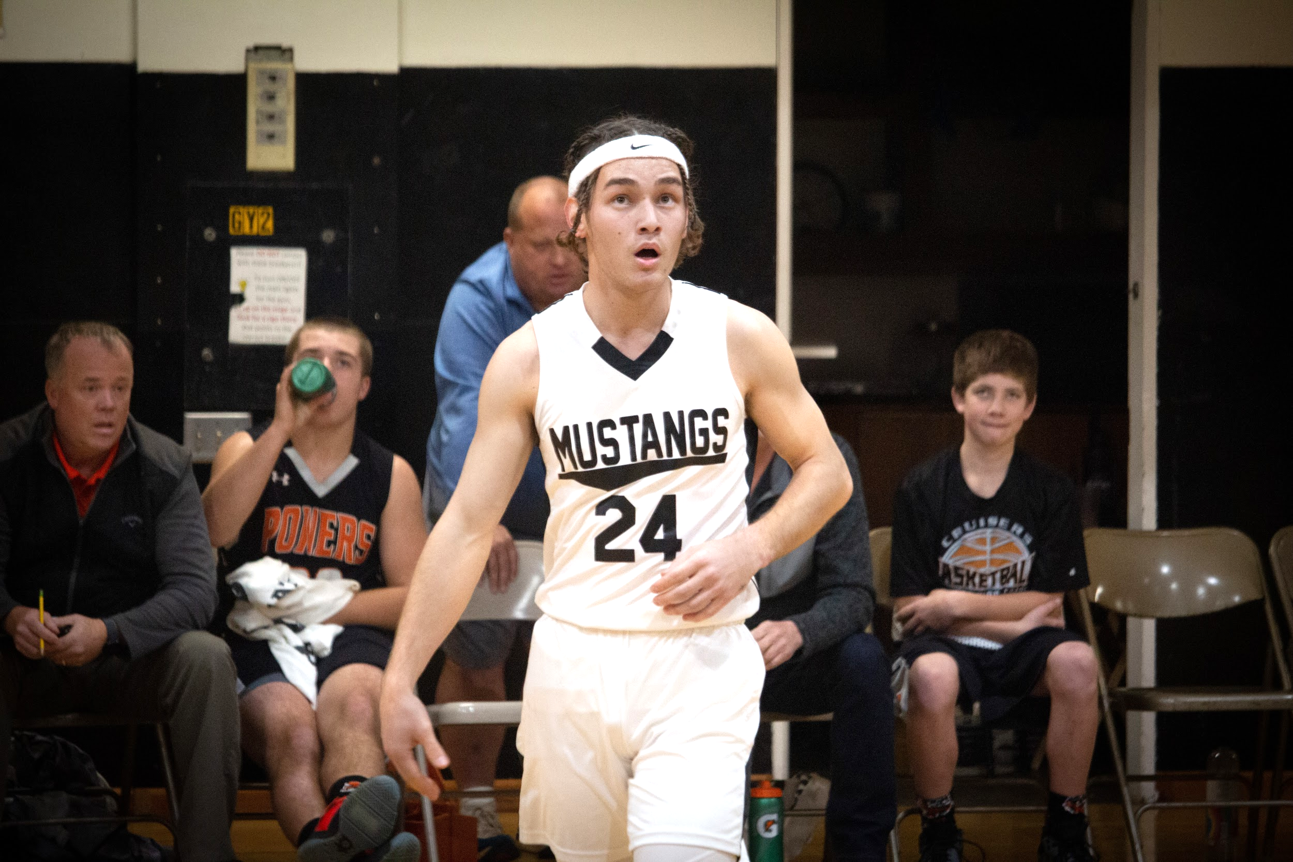

Medical

Accidents
All accidents, even minor ones, occurring anywhere on campus must be reported to the staff member in charge of the activity or to the appropriate dean. Accident reports must be filled out within 24 hours of the accident by the person injured in order to receive coverage under the student accident insurance policy. Report forms can be obtained from the administrative secretary. Accidents occurring at work must be reported to the work supervisor immediately.

Illness
When you are ill, please follow this procedure:
- Before classes begin:
  - Dorm students must notify the dean on duty before 7:30 AM to be assessed by the school nurse and possibly be placed on “Sick List.”
  - Parents of village students must notify the school office to place their child on “Sick List”
After classes begin:
- If you become ill during a class or at work, you should report to the teacher or work supervisor before leaving any class or work. Then the student should go directly to the nurse for evaluation.
- It is your responsibility to communicate with your teachers about any missed work, even after being placed on sick list. If placed on sick list this will be automatically sent to all staff.
- If you are ill enough to be on sick list, you must stay in your room until the next day, leaving only to use the restroom and to pick up your meals when called down by the dean or another designated dorm staff.
- While you are on “Sick List” you may not have visitors in your room and you may not visit other rooms.
Your classes or On-the-Job instructional (OJI) responsibilities may not be excused if you do not abide by these regulations.

Once village students are on campus they need to see the Nurse if they are feeling bad or call their parents to come and get them.. If this occurs, the parents must notify the administrative front office.

Milo Medical copay and prescription costs are the parents’ responsibility.

Medical Appointments
Please note that all routine medical appointments should be made to coincide with regularly scheduled home leaves. If an appointment is needed due to illness or injury, you must contact the Dean on Duty or the School Nurse.
Each student is responsible to provide the written continuing care instructions along with any medication and documentation from the physician or nurse with each doctor’s visit to their dean.

Medications
No staff member other than the school nurse and deans may dispense medications to any student, including over-the-counter medications such as aspirin, ibuprofen, etc. A consent form for this purpose is a part of the registration packet.

Students may keep certain medication on campus and self-administer with a doctor’s written acknowledgement of the student’s ability to self-administer. The medication must be stored in a locked container only accessible by the student.
In the case of suspicion of abuse of any medication, the MAA administration and deans reserve the right to confiscate medications and dispense the medications for that individual.

Health Insurance
Health insurance is required for every student to have in case of illness or accident while enrolled at Milo. Medical copay and prescription costs are the parents’ responsibility. Please contact the school office if a student does not have health insurance.

Horse Rides
MAA’s horsemanship program provides several opportunities for students to spend time around horses. Horsemanship classes, horse rides for all students, areas in which students can observe or pet horses on Milo’s campus, and more.

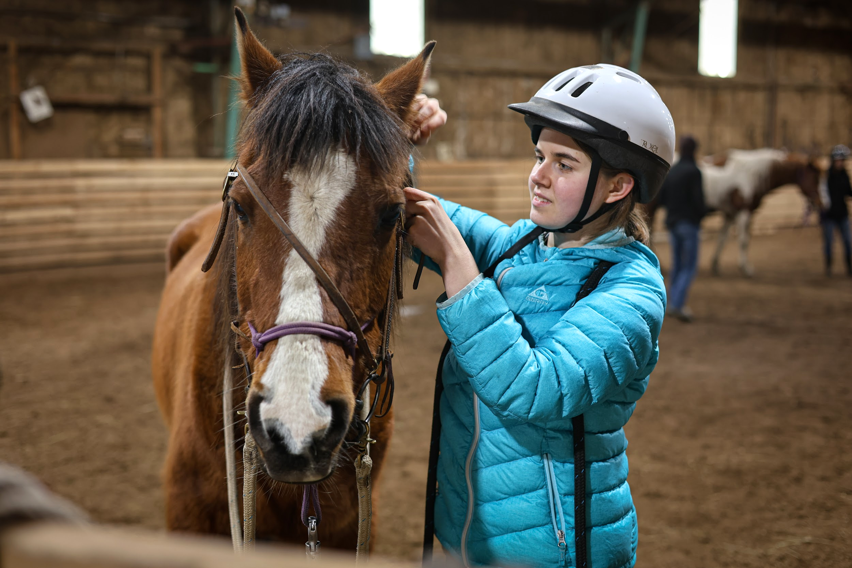

Social Health Development

Humans were created as social beings. Friendship and association with others are natural, basic human needs. Social skills such as teamwork, leadership, consideration of others, conflict resolution, and good manners must usually be learned. MAA is committed to providing an atmosphere and learning experiences that will enable each student to develop and improve these skills.

Goals
- To regard others as worthy of respect.
- To manifest Christian attitudes of propriety and respect in all social relationships.
- To consider other points of view.
- To exercise self-control and self-discipline.
- To respect the property of others.
- To conduct social functions which adhere to biblical principles.

Social Relationships
One of the goals of our school is to help students develop wholesome social relationships. The friendships formed here can do much to make the school year happy and successful. Students are encouraged to form many friendships rather than one serious, steady relationship. In order to help students develop a balanced social life, the following guidelines have been established:
- Greeting-type, “catch-and-release” hugs are generally acceptable. Public displays of affection by students are not appropriate on campus or while traveling on school-sponsored activities. This includes holding hands, arms around one another, and kissing. Shoving, wrestling, “piggyback” riding, and the giving of back/shoulder rubs are examples of inappropriate public behavior on our campus. Students sitting together should sit up, without leaning against each other. While relaxing on the floor or lawn, students are expected to maintain enough distance that someone could easily walk between them.
- Students of the opposite gender must remain in lit supervised areas at all times.
- Students who do not follow these guidelines may be placed on “social restriction” for a week. A student’s response when told that they are on “social” will be a factor determining if a longer time is needed. While on “social,” the couple may not be together or communicate with each other in any way. Any couple whose relationship seems unhealthy or inappropriate may be placed on “social.”
- When a student is placed on “social,” it is effective immediately.
- Non Students who are socially involved with students are subject to school policy while on campus.

Social Guidelines
One of the most valuable skills for success in this life and for eternity is that of self-discipline. Those who have learned to manage themselves are able to make the choices that make life good and will rarely need to be disciplined by others. Those who are unable to discipline themselves will cause unnecessary pain to themselves and to others throughout their lives.

When it becomes necessary for staff members to apply corrective discipline, they work within the philosophy and guidelines of the school. Most discipline is accomplished in the ordinary educational environment between the student and either the teacher, supervisor, or dean. Discipline may be imposed for inappropriate conduct not listed in this policy. It is, however, always administered with these factors in mind:

- Is the student being completely honest and forthright?
- Does the student take responsibility for their actions and truly want to change?
- Is the student willing to work with school staff to reach the goals set forth in the mission statement and student statement of commitment?
- What is best for the student and for the school? There are times that the school just does not have the resources or ability to meet the needs of some students. In these cases it is best if they find a school that can better meet their needs.

Confidential information may make it impossible for all facts to be explained to those making inquiries. Nevertheless, the school would encourage dialogue so that judgements will not be made with an incomplete understanding of circumstances.

General Guidelines
- Follow directions of all staff members quickly and quietly.
- Keep hands, feet, and objects to yourself.
- Walk on the right side of the halls, stairs, etc.
- No inappropriate language, teasing, or tattling.
- No gum or candy brought to school.
- Keep cellphones in OFF mode until the student is dismissed by the teacher/supervisor.
- Hats may not be worn in the building.
- No device (phone) and earbud use in classrooms and hallways (unless requested by instructor).
- During On-the-Job Instruction (OJI) no phone and earbud use (unless permission granted by instructor).

Hallways & Restroom Guidelines
- Always speak softly and only if necessary.
- Do not litter or damage school property.
- Do not disturb other classes.
- Take the stairs one at the time.

Cafeteria Guidelines
- Speak softly.
- Use good manners.
- Clean up after yourself; throw all trash away.
- Avoid sharing food.
- No running.

Social Discipline
Responding to unsatisfactory behavior in a school can offer challenges. The balance between holding a child accountable and creating a positive environment for learning is sometimes difficult to achieve, but it is restorative (see the social discipline chart below on next page).

Preventative Practices
- Celebrate the students’ uniqueness and personality, as well as appreciate the background and understanding that caused the behavior. The school focuses on the student’s identity as a preventative approach.
- Have work area practices based on procedures and routines that help us create a safe environment.
- Build community to help us create relationship building through faculty families and small interventions.
- Rely heavily on work ethics principles that help us increase the awareness of values, problem solving, communication, and restorative language.

Responsive Practices
When students demonstrate a resistant attitude to developing good work habits, the responsive practices kick in. The student is placed on the responsive track and referrals are a part of this. When a student has consistently failed to respond to attempts to help him/her improve habits, either the teacher, the supervisor, or the dean will initiate a referral, outlining the opportunities for improvement and the desired outcomes. See Table xx below for more details. For attendance issues definitions see Table xx.
Restorative
Punitive
Permissive
Neglectful
LOW
HIGH
SUPPORT:
Encouragement
Nurture
ENGAGEMENT:
Limit-setting
Discipline
Accountability
HIGH
Costello & Wachtel, 2021

Milo’s social guidelines focus on the improvement of behavior and relationships by moving away from blame and retribution when dealing with unsatisfactory behavior towards social responsibility and self-awareness. They empower students to take responsibility in problem-solving and to develop healthy relationships. They build stronger, safer, and more inclusive, caring communities by including a range of preventative and responsive practices to resolve them when they appear.

MAA’s social discipline practices include a number of formal and informal events to build and maintain relationships and prevent conflict and harm (preventative practices). It will also repair relationships and resolve conflict managing difficulties and disruptions (responsive practices). This is what restorative discipline is.

Withdrawal
Students who have been dismissed from school or who have withdrawn to avoid discipline are required to make advance requests for permission from the Ad Council if they wish to visit the campus within the current school year.

Appeal Process
All discipline is subject to appeal. An appeal must contain information not previously considered and must be submitted in writing to the Principal. The Principal mediates at every level and ultimately decides whether the appeal continues to the next level. The appeal is to be directed in the following order:
Level 1 Administrative Council
Level 2 Leadership Team
Level 3 Operating Board
Every attempt will be made to resolve problems at the lowest level.

Social Definitions

AWOL
AWOL is defined as leaving the Milo property without the prior approval of the dean. Approval gained through deceit or misrepresentation of intentions is invalid and will result in disciplinary action.

Bus Decorum
- Students are to stay in their seats, not sit on seat backs or lie on the floor.
- The ceiling and window Emergency Exits are to be used only in case of an emergency as directed by the driver.
- There is to be no boisterous or rowdy conduct on the bus at any time.
- Nothing is to be thrown from the bus.
- No part of the body or any other object should be outside the bus.
- All students are responsible for reading and obeying the rules posted on the bus.

Cheating Policy
First Offense
A student caught cheating will receive a zero grade on the assignment/test. The student must write and sign a letter to his/her parents describing the circumstances. This letter will be enclosed with a letter from the Administration to the parents and sent by certified mail. In addition, any offices held by the student will be forfeited for the remainder of the school year.
Second Offense
The student will receive a zero grade on the assignment/test. In addition, the student will be suspended for three days. No makeup work will be allowed for the period of suspension.
Third Offense

The student will be expelled. No arrangements will be made with MAA to enable the student to complete the grading period through Milo.

Entertainment Criteria
Entertainment media which contains the following material is not in line with the spiritual and moral principles by which MAA operates. Therefore, written material, performances, or recordings containing such material are inappropriate and unacceptable on campus.
- sexually explicit or graphic lyrics
- Satanic, occult, or sacrilegious material
- profane or vulgar language
- violent or hateful lyrics
- material degrading to any race, religion, gender, or individual
- material that would lessen the ability to discern good from evil or lessen an interest in spiritual things

Gambling/Playing Cards
Because of their association with gambling, and the possibility of their being a stumbling block to others, poker cards are not to be used.

Insubordination
Level 1– Failure on the part of a student to follow the request or direct command of a staff or faculty member.
Level 2– Failure on the part of a student to follow the request or direct command of a staff or faculty member, accompanied by expressions of disrespect.

Hazing and Fighting
Hazing occurs when someone attacks, disturbs, torments, or forces another to do something that person does not want to do.
Fighting is not acceptable at MAA. There are many ways that mature people can think things through and settle their differences without resorting to violence.
Students who become involved in fighting will be brought before the Discipline Committee. All parties involved will be suspended, unless it was an obvious assault by one or more participants. First time violations may result in withdrawal. Students who either encourage or incite a fight through teasing or harassment of another student are subject to the same suspension as are those who are actually fighting. Students are encouraged to utilize the school’s counseling, administrative, or teaching staff to help resolve differences instead of resorting to fighting.
When an injury inflicted by one student on another student or staff requires medical attention, the perpetrator and his/her guardian will be responsible for the medical fees. This will be true no matter who provoked the fight.

Substance Abuse Policy
MAA believes in promoting a drug free society. Our goal is to teach students to make healthy lifestyle choices which exclude substance use on or off campus while enrolled at MAA.
Being in possession of, using, or being under the influence of any illegal drug, intoxicant, inhalant, or alcoholic product is prohibited on or about the school premises or any school sponsored activity. Distribution, sale, or trafficking of drugs or alcohol will result in withdrawal for the remainder of the year. MAA reserves the right to contact law enforcement agencies when the law has been broken.
Self-referral: Students who are concerned about their involvement with dangerous drugs are encouraged to ask a staff member for assistance. The staff member will help the student contact appropriate resources. All self-referral under the substance abuse policy will be treated without disciplinary action, if assessed, and if the ensuing recommendations are followed.

Drug Testing
Application to MAA assumes your willingness to participate in drug testing if requested by the Administration of Milo Academy.

Firearms, Weapons and/or Threats of Violence
The protection of our children and young people must be of the highest priority. While recent reports indicate that schools, by and large, are safe and orderly places of learning, we also recognize that we live in a violent society, and as such our schools are not immune to the possibility of violence. For this reason, the following policy applies to all schools within the Oregon Conference of Seventh-day Adventists.
Students are prohibited from bringing any firearm or weapon to school or to a school-sponsored activity. A student who possesses a weapon or who carries, exhibits, displays, or draws any weapon or any object which can be mistaken as a weapon, or any item apparently capable of producing bodily harm in a manner which, under the circumstances, manifests an intent to intimidate another or warrants alarm for the safety of others shall be subject to immediate discipline up to and including suspension or expulsion. Parents and the appropriate law enforcement agencies shall be notified. Appropriate counseling is required before the student returns to school.
Verbal threats of violence or threats involving firearms or weapons made by students to other students or to school employees are to be taken seriously and must also be dealt with in a determined manner. Parents are to be notified and there may be a need for possible police involvement. Appropriate discipline might include assignment to detention, suspension, or expulsion depending on the nature and severity of the threats.

Drug Definitions
Dangerous Drug– Any drug, obtainable with or without a prescription, that can be used in a manner dangerous to the health of the user. This includes, but is not limited to, tobacco, alcohol, marijuana, amphetamines (stimulants), barbiturates (depressants), cocaine, codeine, inhalants, heroin, hallucinogens, and misuse or abuse of over-the-counter and prescription drugs.
Use– Whenever a student has consumed, taken, or is under the influence of alcohol, tobacco, or illegal drugs, or has abused over-the-counter or prescription drugs at any time.
Distribution– To share and/or sell dangerous drugs to other students or persons on or near school property or during school-sponsored activities.
Possession– To have dangerous drugs (which have not been prescribed for you personally by a physician) on your person or within an area of your control including, but not limited to, car, locker, dorm room, books, clothes, on or near school property, at any time.
Found– Positive proof that the student has involvement in abuse, possession, or distribution of dangerous drugs. Self-referral is no longer an option under these conditions.

Behavioral Contract
A document outlining specific expectations for a particular period of time for a student who has not been able to comply with behavioral guidelines.

Discipline Policy for Handicapped Students
Handicapped students will be disciplined when their behavior:
- Is not handicap-related.
- Poses a risk to others.
- Poses a physical risk to him/her-self
- Requires a cooling-off period to prevent future occurrence of disruptive behavior and/or
- Demonstrates a need for a change in educational placement because of constant disruption to the learning environment.

Freedom of Expression
Students are entitled to present their personal opinions as long as these expressions do not disturb the educational process. All published material must obtain prior approval from the principal or his/her designee and bear identification as to the author and distributing organizations. The distribution of such material must take place at a reasonable time and location approved by the principal and must not interfere with the orderly school process. Such material must be free of libel, obscenity, and defamatory statements against any person.

Sexual Harassment Policy
The Oregon Conference of Seventh-day Adventist Office of Education (The Oregon Conference) prohibits unlawful discrimination and harassment of any kind. This policy defines these terms and provides a complaint procedure for all persons described in subsection (5)(b) of Senate Bill 197 (SB197) who believe they have been victims of prohibited conduct.
This policy includes sexual harassment of students by students or staff members; sexual harassment of staff members by students or other staff members; and sexual harassment of persons described in subsection (5)(b) of SB197 by students or staff members. It may also encompass any conduct that a reasonable person in the individual’s circumstances would consider unwelcome, hostile, intimidating, threatening, humiliating, abusive, offensive, or violent behavior that is not necessarily illegal, but is still prohibited by this policy.

Discrimination and Harassment
It is the Oregon Conference policy to provide a learning environment free from discrimination or harassment on the basis of race, color, religion, sex, national origin, marital status, age, or physical or mental disability, or any other characteristic protected by federal or state law. Beyond the legal requirements, it is the expectation for all members of our school community that we follow Biblical counsel and Jesus’ example to respect and affirm every person as made in the image of God and loved deeply by Him.

It is our policy that all students, staff members, volunteers, and visitors to the school are entitled to a respectful and productive learning environment free from behavior, action, or language that constitutes harassment or discrimination. The “school” includes when any individual is on school premises, at a school-sponsored off-site event, traveling on behalf of the school, or conducting school business, regardless of location.

Sexual Harassment
Sexual harassment is a form of harassment and includes, but is not limited to 1) unwelcome sexual advances, requests for sexual favors, or other conduct of a sexual nature, explicit or implicit; 2) unwelcome verbal or physical conduct that is sufficiently severe or pervasive to have the purpose or effect of unreasonably interfering with performance or creating a hostile, intimidating or offensive environment.

Sexual Abuse or Assault
Sexual Abuse or Assault is 1) conduct of a sexual nature directed toward a person younger than the age of consent or a person who is unable to give consent; 2) unwanted conduct of a sexual nature that is inflicted upon a person or compelled through the use of physical force, psychological or emotional manipulation, threat, or intimidation.

Prohibited Conduct
This policy prohibits conduct based on an individual’s protected status. The following examples, while not comprehensive, represent prohibited behavior:
- Physical harassment, including but not limited to unwelcome physical contact such as touching, impeding or blocking movement, or any physical interference;
- Verbal harassment, including but not limited to disparaging or disrespectful comments, jokes, slurs, innuendoes, teasing, and other sexual talk such as jokes, personal inquiries, persistent unwanted courting and derogatory insults;
- Nonverbal harassment, including but not limited to suggestive or insulting sounds, obscene gestures, leering or whistling;
- Visual harassment, including but not limited to displays of explicit or offensive calendars, circulation of derogatory content, posters, pictures, drawings or cartoons that reflect disparagingly upon a class of persons or a particular person;
- Sexual harassment, as described above, including but not limited to unwelcome sexual advances or requests for favors in exchange for conduct of a sexual nature;
- Sharing, requesting, or having possession of inappropriate photos of a sexual nature. (Sexting is the sending of nude or sexually explicit images by cell phone, smartphone, or other electronic devices. Teenagers in Oregon who share nude or sexual images of minors may be prosecuted under the state’s child pornography laws.)

Disciplinary Action
The Oregon Conference will not tolerate discriminatory conduct, harassment, or sexual assault. Any individual found to have engaged in such conduct may face disciplinary action, up to and including expulsion.

Protection Against Retaliation
The Oregon Conference prohibits retaliation against any individual for filing a complaint regarding conduct in violation of this policy. The Oregon Conference will not tolerate retaliation against any student or staff member for raising a good faith concern, for providing information related to a concern, or for otherwise cooperating in an investigation of a reported violation of this policy.

Reporting Procedure
- Any student or staff member aware of or experiencing discrimination, harassment, or sexual assault at school or participating in school-related activities should report that information immediately and may make the report verbally or in writing to an immediate supervisor or school administration.
- The school administrator/principal shall contact his/her superintendent to report any information or incident he/she becomes aware of regarding discrimination, harassment, or sexual assault.
- If the report is of sexual abuse or assault and involves a student, the staff member shall also immediately fulfill his or her duties as a mandatory reporter by contacting either local law enforcement or the Child Abuse Hotline for their state.
- The Oregon Conference will work in cooperation with the principal to coordinate efforts to ensure the student/staff is protected and to promote a non hostile learning environment by:
  - Providing resources for support measures to the student/staff.
  - Taking any action necessary to remove future impact on the student/staff.
  - Investigating and documenting all complaints.
  - Communicating with involved students/staff and parents. The individual who initiated the complaint and, if applicable, the student’s parents shall be notified:
    - when an investigation is initiated
    - of the protected rights of the student reporting
    - when an investigation is concluded and whether a violation of this policy was found to have occurred
  - documenting action(s) taken.
- Local law enforcement may be involved if required by the facts of the incident.

Time Limitations
Nothing in this policy precludes any person from filing a formal grievance to the Bureau of Labor and Industries’ Civil Rights Division or the Equal Employment Opportunity Commission. Note that Oregon state law requires that any legal action taken on alleged discriminatory conduct (specifically that prohibited by ORS 659A.030, 659A.082 or 659A.112) commence no later than five years after the occurrence of the violation. Other applicable laws may have a shorter time limitation on filing.”

Sexting
Under Oregon's law, it's a crime to possess sexually explicit images of minors, create or share sexually explicit images of minors, or use a minor in a display of sexually explicit conduct. Both adults and minors can be prosecuted under these laws. And because the law doesn't require images to be of another minor, taking or sexting sexually explicit selfies count as crimes. Or. Rev. Stat. §§ 163.665 to 163.689 (2020).

Table 1: Levels of Infractions
LEVEL | CATEGORY | SCENARIOS | ADDRESSED | OUTCOMES
1. CLASSROOM  WORKAREA  DORM  Discipline issues that the classroom teacher, work supervisor, or dean will handle in the context of the relationship with the teacher, work supervisor, dean, or peers without the assistance of the administrative staff. | DISRUPTION | - Yelling, Off task, Out of seat/workstation, Fidgeting, Disorderly, Restroom problem, Throwing problem, Personal speaker misuse, Lights out  - Outburst | By Teacher,  Supervisor or  Dean | - By using classroom, workstation, or dorm rules, it will be up to the teacher / supervisor / dean to address the discipline issue and provide consequences AFTER a verbal warning has been given.  - Level 1 infractions will normally not escalate to a higher level. Repeated infractions on this level will become a level two infraction.  - Addressee (Teacher/Supervisor/Dean) documents incident.  - Parents/Guardians are notified.
 | DISRESPECT | - Rolling eyes, Teasing, Cursing, Cheating, Littering, Defiant  - School sign in/out  - Electronic device | By Teacher,  Supervisor or  Dean
 | PREPAREDNESS | - Dress code, Missing assignments/ work/ materials, Inefficient, Not following procedure, Not a team player, Little initiative, Inattention, Irresponsible, Academic problem, Room inspection, Workstation violation  - Repeated missed punches  - Attendance issues  - Citizenship grade D (quarterly) | By Teacher,  Supervisor or  Dean
2. MODERATE REFERRAL  Discipline issues that require the attention of the administrative staff, but not immediately | DISRUPTION | - Repeated Level 1 disruptive behavior  - Disorderly continual  - Excessive teasing  - Wrong place/wrong time  - Speeding | By Principal or VP | - At the time of the Level 2 discipline referral, the teacher / supervisor will maintain the child in the classroom / workarea to continue with the educational process.  - An incident report will be sent to the administrator as to the nature of the infraction at which time the administrator will make every effort to see the student in a timely manner.  - A report is emailed to the parents.  - A follow up call to the parents is made by either the principal or an administrator  - The administration will attempt to see all Level 2 referrals before the end of the day they occurred; if not, the following morning. After the disciplinary consequences have been administered, the student will be returned to class with the discipline report and record of consequences. There will be mutual acknowledgment by the student/teacher/ supervisor/administrator and the student will return to normal procedures.
 | DISRESPECT | - Repeated level 1 disrespectful behavior  - Vulgar language (directed)  - Extremely defiant behavior  - Argumentative  - Bullying  - PDA | By Principal or VP
 | PREPAREDNESS | - Chronic level 1 preparedness  - Repeated room inspection/workspace violation  - Citizenship grade F (quarterly) | By Principal or VP
3. SERIOUS REFERRAL  Discipline issues that require the immediate attention of the administrative staff. | ILLEGAL | - Weapons  - Illegal drugs/alcohol  - Sexual behavior (verbal/action)  - Fire alarm | By Principal and  Designated Committee | - When making a Level 3 referral, the student involved will be sent or escorted to the office by the referring staff member or taken to the office by an administrator. A completed incident report will accompany the student or be sent to the office immediately after the incident/infraction.  - Report is sent to parents.  - The principal/administrator calls the parents.  - The principal sets up an immediate conference with the teacher/supervisor/ dean, parent, and administrator.  - The principal, teacher/supervisor/ dean, and administrator discuss suspension, parent participation, and other options.  - A behavior plan is written and signed by parent, student, teacher/supervisor/ dean, and administrator, addressing consequences for possible future infractions.  - After consequences have been administered, the student will be returned to class / work / dorm with the discipline report and record of consequences. There will be mutual acknowledgment by the student/teacher/ administrator and the student will return to normal procedures.  - The student may be asked to withdraw from school as a result of Level 3 infraction(s).
 | PHYSICAL | - Assault  - Aggressive / threatening behavior  - Disclosure / allegation of abuse (physical / verbal / emotional / sexual/ neglect) | By Principal and  Designated Committee
 | DEFIANCE | - Defiant (continued Level 2 interventions)  - Vandalism / property damage  - Theft  - Runaway/AWOL (whereabouts temporarily unknown)  - Breaking a behavioral/academic contract | By Principal and  Designated Committee

Emotional Health Development

Dorm Discussions

Dorm Worship is a unique time for the residents of each dorm to meet together and listen, learn, and discuss with their deans, peers, and special guests. Spirituality, life lessons, and social issues are among the many topics presented and discussed during Dorm Worship. Dorm Worship meets at 7:30 pm every Sunday-Thursday.

Campus Ministries
The aim of Milo Adventist Academy Campus Ministries is to provide practical and spiritual nurture to both students and staff, and connect scholastic education with spiritual growth in Christ. Although spiritual matters are very personal in nature, it is the privilege of the campus ministry team to endeavor to create a safe, and conducive climate where students can achieve mental, emotional, and spiritual health. The ultimate goal is to educate, mentor, and train students for effective service in their homes, churches, and communities.
We are equipped with a resident pastor/chaplain and student chaplains who are carefully chosen, spiritually-minded resident assistants, dorm chaplains, deans, Bible instructors assigned to each student group, and daily faculty-family contributors.
Visiting speakers and mentors are regularly invited, and the school benefits from a large range of spiritual guides and mentors within and without. Facilities utilized for mentoring include:
- The Campus Ministries Office
- A beautiful, central-campus church facility
- Staff Offices
- Dorms
- The Student Center
- Nearby Camp Umpqua Lodge
- Various campus settings, such as the Gazebo
The Campus Ministries Office is in a central location in the Admin Building and serves as a safe place for students to have a welcome retreat to study, or to have their spiritual needs met. Spiritual friendship or peer counseling sometimes occurs between student chaplains and other students, but the more serious, approved, professional counseling is available through the deans, counselors, and administration.
Student chaplains are expected to have an apparent relationship with Jesus, be courteous and friendly, be respected by their peers, be willing to listen, be cooperative with their staff mentors, demonstrate leadership capabilities, be organized, achieve academic excellence, and share loyalty to the purpose and mission of Milo Adventist Academy.

Chapel
Boarding school is different from day school. You will not live at home anymore, and you could be far from family and friends. You’ll take new classes, meet new people, and take on more responsibilities than you have before. You might be involved in sports and clubs, and On-the-Job instruction. It’s lots of new, lots of change. Chapel can help you adjust to all of these changes.

Even when everything feels unfamiliar, your faith can provide a sense of comfort because it is familiar. It’s a part of who you are. Through regular attendance (mandatory), you can strengthen your faith, as well as your emotional health. You learn academic lessons in the classroom. In Chapel, you learn weekly lessons that affirm your faith, and shape and strengthen your character. These teachings help give you the fortitude to resist temptations along your high school journey. There will be many. Not everyone is as determined, focused, and passionate about where they’re going as you are. Even you may be tempted to compromise your values to fit in. These occasions are uncomfortable but with regular Chapel attendance, you can learn how to navigate them with grace.

Counseling Sessions
Mental and emotional health is important for a healthy, balanced lifestyle. Students are encouraged to explore positive coping mechanisms and reach out to parents and staff for support. Milo offers counseling for students who might need extra support or further education on mental and emotional health. Staff, students and parents may speak to the counseling coordinator to be added to the counseling schedule. Milo’s counselor meets with students weekly.
For students with continuous and ongoing mental and emotional health needs the school counselor may call for a Care Plan meeting.
A Care Plan meeting is a collaborative effort between the Head Dean (of the student in question gender), the School Counselor, the student themself, and the Parent/Guardian. The Care Plan will determine the expectations of care outside of Milo the student is required to participate in, if any, what assistance in facilitating outside care is needed from the school, the expectations of behavior and engagement with the Care Plan from all stakeholders, and the consequences for failure to abide by the Care Plan.
Parents/Guardians of Domestic Students are expected to arrange and be responsible for outside care (ie counseling or psychiatric appointments) preferable during Home Leaves and Breaks they will also be financially responsible for any transportation provided by the school.
Parents/Guardians of International Students will retain financial responsibility for outside care and transportation, however the school will assist in the making of appointments and transportation.

Mentorship

Faculty Families
All students are assigned a ‘family’ on campus. We call them Faculty Families and they meet 4 times per week for 15 minutes every time. These families may also have separate gatherings, such as: going to a staff house to share a meal, having vespers together, going to town, among others.

This helps Milo staff members to make sure they have a ‘finger on the pulse’ in all students as they journey through their experience at Milo. This allows us to identify specific needs, address certain issues with the entire student body in a timely manner, form a special bond with students, and give them a sense of belonging.

Accountability
At Milo, staff members start each learning period (class or on-the-job instruction) holding students accountable for exactly what they’ll accomplish during that time.

Consistency
True relationship building depends on consistency, both in terms of meeting regularly and continuously following-up on students’ interests and goals.

Personable
Our staff is always willing and able to meet with students to listen and coach.

Intellectual Development

Milo Adventist Academy is committed to providing an atmosphere and learning experiences that will enable each student to achieve the intellectual excellence of which he or she is capable.

Goals
- recognize that God is the source of both knowledge and wisdom.
- become a thinker rather than a mere reflector of others’ thoughts.
- gain a foundation of knowledge and skills that will enable him/her to excel at higher levels of education.
- establish the habits of self-discipline necessary for success in all future endeavors.

Graduation Requirements

General Program
The listing below outlines minimal requirements for graduation as set forth by the North Pacific Union Conference of Seventh-day Adventists and the state of Oregon. Students may be accepted into some colleges with a general diploma, but will likely be admitted on a probationary basis until prerequisite classes have been successfully completed.

Requirement Credits per year*
Bible 10
English 40
Science (including one lab science) 30
Mathematics (must be Algebra 1 and higher) 30
Keyboarding/Computer Literacy‡ 10
Computer Literacy 10
Global Studies 10
US History 10
Economics 5
Government 5
Physical Education** 10
Health 10
Technology/Practical Arts course 10
Fine Arts 10
Electives** 30-50
Total Credits 240

* Ten credits represent the equivalent of 130 hours of teacher-student classroom time.
** A maximum of 35 credits in either music or PE may be allowed toward the required number of credits for graduation.

College Preparatory Program
Although students may be accepted into some colleges without taking all the courses listed below, the requirements for the college preparatory diploma include high school courses most often required for entrance into public and private four-year colleges.

Requirement Credits*
Bible 10
English 40
Science (including one lab science)‣ 30
Algebra I 10
Geometry 10
Algebra II (grade of C or better) 10
Keyboarding/Computer Literacy‡ 10
Global Studies 10
US History 10
Economics 5
Government 5
Physical Education ** 10
Health 10
Technology/Practical Arts course 10
Foreign Language or Math & Science Enrichments 20
Fine Arts 10
Total Credits 240
‣ College Prep Science options:
Physical or Earth Science, Biology, Physics, Chemistry, and Anatomy.
‡ Demonstration of the ability to type 40 words per minute is required. Milo does not offer typing classes.

Student Records
Our school operates in compliance with the Family Educational Rights and Privacy Act (FERPA). It is our goal to maintain confidentiality regarding student information and records. Student information and records will not be disseminated without parental or legal guardian permission. A parent, legal guardian, or eligible student may inspect and review education records upon request. We will comply with a request for access to records by a parent, legal guardian, court order, or eligible student within a reasonable period of time.
Authorized school personnel shall have access to students’ records. The parent or legal guardian shall have access to his/her child’s records upon written request to the principal. If a student is 18 years old or older, he/she has the right to determine who, outside of the school the school system, may have access to his/her records. A noncustodial parent shall be given a copy of the child’s current scholastic records upon written request and presentation of a copy of the court-ordered visitation rights to the principal. A copy of the court order shall remain in the child’s folder.
A student’s records may be released to other school systems upon the written request of the parent or guardian, or student if he/she is 18 years old or older. A student’s records may also be released to other school systems upon their request, provided that notification is given to the parent or legal guardian, or student if he/she is 18 years old or older. No official records will be released for graduates who have an unpaid account.
Parents have the right to request that the school withdraw material from a student’s record. Refusal by the school entitles the parent to a hearing to determine if material is accurate and appropriate. If at the hearing, material is ruled to be accurate, material remains in the file, but parents may prepare a statement to be placed with the materials stating their objection. The statement is to be made available with objectionable material whenever access is permitted.
Directory information may be made available for noncommercial uses by the school principal without the prior consent of the parent. However, at the beginning of each school year, the parent may request that all or part of such information not be made available.

Course Descriptions
For descriptions of the current courses, see the Milo website: www.miloacademy.org

Minimum Class Load
The minimum class load for Freshman - Juniors is 60 credits for the school year and 50 credits for Seniors, not including work credits or correspondence work, with no less than 30 credits per semester for Freshman-Junior and no less than 25 for Seniors.

Four-Year Plan
Typical College Preparatory

Freshman
Bible I: Creation/Life of Christ 10
English I 10
Pre-algebra or Algebra I 10
Physical Education 10
Keyboarding/Computer Literacy 10
Electives 0-10
Physical Science 10

Sophomore
Bible II: Exodus/Acts/Reformation/Ch. Hist. 10
English II 10
Geometry 10
Biology 10
Global Studies 10
Health 10
Electives 0-10

Junior
Bible III: Salvation/Daniel/Revelation 10
American Literature or British Literature (Alternating years) 10
Algebra II 10
Chemistry or Physics 10
US History 10
Elective 10-20

Senior
Bible IV: The Christian Life 10
American Literature or British Literature (Alternating years) 10
Government 5
Economics 5
Math (Pre-Calc or Calculus),
Science (Chemistry or Physics), or elective 10
Foreign Language (optional) 10
Elective 10

Class Placement
Class placement is determined by the number of completed credits recorded on the official transcript. Previously earned credits must be officially recorded with the registrar within the semester of enrollment to avoid adjustment of class placement and/or loss of class office. A maximum of 35 music and PE credits can be applied towards the required number of credits for class placement.

Senior
Students who have documented 180 earned credits and who need no more than 60 credits of required classes in order to graduate. Graduates shall have completed four years in a regular program of studies or an approved acceleration program.

Junior
Students who have documented at least 120 earned credits.

Sophomore
Students who have documented at least 60 earned credits.

Freshman
Students who have completed the eighth grade satisfactorily, have been promoted to grade nine, and have signed up for 60 credits.

Enriched Diploma
Students may earn an enriched diploma by earning an overall cumulative GPA of at least 3.0, a GPA of 3.5 in the respective area, and completing these requirements:

Mathematics
Algebra I 10
Geometry 10
Algebra II 10
Calculus 10

Science (40 units credit from these)
Physical Science 10
Earth Science (transfer credit only) 10
Biology 10
Physics 10
Chemistry 10
Anatomy (transfer credit only) 10

Acceleration
Acceleration is seldom advisable. Students considering it should counsel widely with parents and registrar before making an application. The NPUC policy is available from the Registrar. Application to the Curriculum Committee must be made by the end of the Fall Semester of the sophomore year. If approved, the student will never have junior status.
In order to accelerate the student must have met the following requirements:
- Have a composite score at the 85th percentile or above on standardized testingMaintain a cumulative GPA of 3.5
- Complete all regular graduation requirements
- Have satisfactory citizenship
- Be a Milo student at least one semester before applying

Testing
MAA offers a wide assortment of inventories and tests to meet students’ needs. These include achievement, college entrance, career interest, and personality tests, including but not limited to:
- MAP freshmen, sophomores, juniors, and seniors
- PSAT* juniors
- SAT* seniors
- ACT* juniors and seniors
*These tests are available to lower classes upon request. These tests are not required and students are responsible for paying the associated fees.

Course Offerings

Bible
Bible I: Beginnings/Life and Teachings of Jesus (9th) 10
Bible II: History of God’s People (10th) 10
Bible III: Salvation/Daniel/Revelation (11th) 10
Bible IV: The Christian Life (12th) 10

English
English I (9th) 10
English II (10th) 10
American Literature & Composition (11 & 12th) (even yrs) 10
British Literature (11 & 12th) (odd yrs) 10
Writing Workshop (9 - 12th) 10

English Language Learning
English Mastery*** 10

Fine Arts
Drawing 5
Fabric Art (11-12th) 5
Folk Art (11–12th) 5
Music
Band (9–12th)t 5/year
Choir (9–12th)t 5/year
Handbells (9–12th)t 5/year
Lessons (inst., piano, voice)(9–12th)t 5/year
One Voice (audition only) 5/year
Painting (odd years) / Pottery (even years) 5

Mathematics
Pre-Algebra (9–10th) 10
Algebra I (9–10th) 10
Geometry (10–12th) 10
Algebra II (11–12th) 10
Pre-Calculus (11–12th)t 10
Calculus (11–12th) 10

Modern Language
Spanish I (9-12th) 10

Physical Education/Health
Health (10–12th) 10
Physical Education I (9-12th) 10

Publications Production
Yearbook: Trillium (10–12th)* 10/year
* Requires both Graphic Design and Photography knowledge.

Science
Physical Science (9) (lab) 10
Biology (9–12) (lab) 10
Physics (10–12) 10
Chemistry (11–12) (lab) 10

Social Studies
Global Studies (10) 10
US History (11) 10
Government (12) 5
Economics (12) 5

Technology/Practical Arts
Advanced Foods (11–12)* 5
Automotive Service (10–12)* 5
Computer Literacy (9) 10
Family & Consumer Science (10–12) 5
Keyboard Challenge** 5
Metal Fabrication (10–12)*(odd years) 5
Woodworking (10–12)*(even years) 5

*Non-required classes are offered as needed subject to student interest and staff limitations. Extra fees for materials may be required.
**Not actual class. Demonstration of ability to type 40 wpm required before graduation.
***International students only

Adding/Dropping Classes
Class schedules must be approved by the Registrar at the time of registration. To add or drop a class, the following procedure is required:
- Talk with your parents and with the teacher about your reasons for wanting to add or drop the class. Ask your parents to call or email the Registrar at registrar@miloacademy.org to give their approval for the change.
- Secure a Change of Program voucher from the Registrar.
- Obtain signatures of the course instructors involved.
- The change in class schedule is not official until the completed voucher is returned to the Registrar. If dropping a class, the student will need to continue attending class until that time to avoid accumulating attendance points.
Classes may be added during the first week of each semester and may be dropped during the first two weeks of each semester. If the class is dropped before Friday of the second week, it will not appear on the transcript. Classes dropped after the two-week deadline will appear on the transcript with a notation of WP (Withdrawal Passing) or WF (Withdrawal Failing). Classes may not be dropped within ten school days of the end of the semester. At times students may be admitted to classes after the 1 week period, however, this is highly discouraged as the student is responsible for making up all of the work that was missed all the way back to the beginning of the semester.

Correspondence Courses
- Applications to receive credit for correspondence courses must be submitted to the Curriculum/Academic Standards Committee for approval in order for credit to be accepted by MAA. No more than 25% of your total semester periods required for graduation may be from correspondence courses.
- Students may be enrolled in no more than one correspondence course at a time.
- Correspondence schools that are approved include Home Study International, University of Missouri Independent Study, Indiana University Independent Study, the University of North Dakota, and The Keystone School
- Examinations must be sent by the correspondence school to the MAA Registrar.
- Seniors must complete all correspondence course work by the beginning of second semester. If this deadline is not met, senior class standing, including participation in senior class events and senior privileges, will be suspended until a transcript is received for the courses required for graduation. If the course is available on campus during the second semester, the student may choose to enroll in the class and retain senior class standing.
Exceptions to the policies above must be petitioned to the Curriculum/Academic Standards Committee.

My son has grown so much in maturity and responsibility under your care… We have been impressed at the incredible commitment to the school and the students when I talk to you on the phone and when I visit in person.
A PARENT

Outside Credit
Credits earned during the summer or during the school year in a program other than at MAA are designated as outside credits. A request must be submitted in advance to the Curriculum/Academic Standards Committee for approval of any outside credits to apply toward graduation at MAA.
Homeschool credits or courses from a nonaccredited school may be accepted but will be recorded as pass/fail credits only on the MAA transcript according to NPUC Code 2430:98.
Outside credits not officially documented within the semester of enrollment may require adjustment of class placement and/or loss of student office.

Grading

Grading Period
Milo Adventist Academy operates on the quarter/semester system. Each school year consists of two 18-week semesters. Each semester is divided into two 9-week quarters.

Grade Reports
Quarterly Grade Reports: Emailed to parents/guardians.
Semester Reports: Emailed to parents/guardians. These are permanent and are recorded on the transcript.

Grade Points
Upon receipt of a grade report, the student or parent should carefully check it for accuracy. Any corrections must be taken care of within three weeks. The following chart describes the grading system and the honor points associated with each grade. Credit is awarded only for academic classes in which a student has earned a grade of A, B, C, D, E, P, or S.
Grade Description Points
A Superior progress & quality of work 4
B Good progress & quality of work 3
C Average progress & quality of work 2
D Below-average progress & quality of work 1
F Failing work 0
I In Progress 0
WF Withdrawal failing 0
WP Withdrawal passing 0

Academic Standing

Good academic standing
Having no current grade of F in any class or no more than one class with a current grade of D.

Unacceptable academic
Having a current grade of F in any class or having more than one class with a current grade of D. See also eligibility. Any student who receives failing grades in the same two or more classes for two consecutive grading periods will be considered for the reluctant learner policy.

In Progress
A grade of I (Incomplete) is given when, for legitimate reasons (e.g., extended illness, mastery style learning), the student is unable to do sufficient work in any given period to receive a passing grade. Incompletes may not be used to make up for excessive absences or habits of procrastination.
Except in Mastery style classes, an incomplete must be removed within three weeks after the close of the grading period for which it was given. Incomplete grades which have not been cleared by then will automatically be changed to an F.

Mastery styled classes have grades based on work completed through an entire semester or year. For these courses, an Incomplete is sometimes used as a report card place holder until the student completes the required amount of work and a final grade can be calculated. Communication with the teacher is critical to knowing how far along your student is in the course.

Tutors
Milo staff recognize that students learn at different rates and in different ways. Because of this, student tutors are made available to assist students who desire additional help with assignments.
Parents may also choose to arrange privately with other students or with non-student tutors at their own expense. All such tutors must be approved by the administration. Deans must approve the locations of the tutoring, and they will expect to receive regular progress reports from the tutor.

D, F and I and Eligibility
To ensure students are doing well academically, at times, it becomes necessary to provide added support to students that are struggling in their classes. To help us with this, each Friday afternoon, the D, F and I list will be released to the Staff and the Deans will let students know who is on the list. Students that find themselves on this list have either 1 F or 2 D’s in any subject and cannot be removed from the list until the next week when the new list is released. The only exception is if the student is on the list because of a teacher’s mistake.
Students on this list will be provided with the following opportunities for more study time;
- Students will be ineligible for any Varsity sports until the next list is released that does NOT include their name.
- Dorm students will have special study times in the Dorms as arranged for by their Dean.
- Students will be denied off-campus extra-curricular activities that would interfere with class or study hall.
- Students that have leadership positions and are continually on this list may be reassigned to a different job that has less demands on their time.
The purpose of this list is not to punish students but to allow them more study time to be successful.

Graduation
Graduation at Milo Adventist Academy is a formal occasion honoring the graduating seniors. Candidates must have been in residence for the full semester immediately preceding graduation. To participate in these exercises, a senior must have completed all academic requirements, be a citizen in good standing, and have made payment in full thereby clearing financial obligations to MAA.
- Students who have completed graduation requirements will be honored during the weekend activities.
- Members of the junior class participate in a specifically defined role.
- Guest speakers, musicians, program format, and program content are to be approved by the school administration and sponsors.
- Students must wear Sabbath meeting attire for all weekend programming.
- Seniors who have Level 3 infraction(s) of the behavior code during the last three weeks of the school year should expect to forfeit graduation privileges.
- Seniors are required to attend all scheduled weekend programs, to remain on campus on Friday and Saturday nights, and to abide by all MAA policies.
Any senior who chooses not to cooperate with the standards outlined above will not be allowed to participate in graduation activities. Serious infractions of school rules in the last few weeks of school could result in suspension until after graduation, at which time a special exam fee would be assessed.

Graduation Events
Consecration:
A worship service for and with the senior class during Friday evening vespers.

Baccalaureate:
A spiritual challenge during the church service hour on Sabbath for the senior class to continue in Christian service.
Tribute to Parents:
A Sabbath afternoon presentation to and for the families of graduating seniors.

Commencement:
A general challenge to the graduates, including the awarding of diplomas and scholarships, Sunday at 10:00 A.M.

Academic Recognition
Graduates who meet standards of academic excellence will be recognized with honor cords.
- Gold 3.75 GPA or above
- Silver 3.50 - 3.74 GPA
- Red 3.00-3.499 GPA
- Black Enriched diploma
All cords will be awarded based on the student’s cumulative GPA at the end of the final semester of the senior year.

Checkout Times
Freshman and sophomore dorm students should check out of the dormitory and go home following their final tests on Thursday before graduation.
Only seniors, juniors, and those freshmen and sophomores with family members graduating or those who are working may remain in the dorm during graduation weekend; all non-seniors will be expected to move out of their dorm rooms to provide space for the families of the graduates.
All students not working during the summer should be checked out of the dorm by 4:00 P.M. on graduation Sunday.

Attendance Policy

There is a positive relationship between class attendance and academic success. Irregular attendance is one of the prime factors associated with student failure and frustration with the school experience.
MAA’s attendance policy has been designed to encourage regular attendance in classes and reflects these underlying aspects of school philosophy:
- Community and business surveys regarding educational goals continually stress the development of reliability and responsibility as high priority objectives.
- Students in this age group should be expected to exercise self-discipline and responsible behavior.
- Students who attend classes regularly learn better and get better grades.
- Attendance is the responsibility of the student.
- Monitoring student attendance is the responsibility of the parents.
- Regular attendance at all appointments is expected of every student. This includes classes, assemblies, music appointments, on-the-job instruction, residence hall worships, faculty family, cafeteria clean up, community service projects, and weekend religious programs.
Our society is highly time-dependent and we want to prepare our students to function in it. We can educate only those students who are present, and interruptions caused by tardiness/absence are a serious drain on effective teaching time. For these reasons we have instituted the following attendance policy.

Policy
Students begin the semester with an A. See below to see how they can lose points depending on attendance behaviors.

M Unresolved missed OJI punches ¼ point
T Late for anything mentioned in item 6 above ¼ point
T10 Over 10 minutes late ½ point
EpA Expected absence ½ point
EcA Excused absence 0 points
UA1 Unexcused absence for a period 1 point
UA2 Unexcused absence for a block 2 points

Eligibility
Eligibility will be determined by the DFI list. DFI for attendance will be determined by totaling the attendance points for the 4 previous weeks of school.

Grades will be as follows:
A 0 - 1 point
B 1.25 - 2 points
C 2.25 - 3 points
D 3.25 - 4 points
F 4.25 or more points

Should a student miss more than 20% of a given class due to ANY absence, the student will be withdrawn from the class. The following chart explains the number of days missed based on percentages.

Days/wk | Days/sem | 20% | 10% | 5%
2 | 45 | 9 | 4.5 | 2.25
4 | 72 | 14.4 | 7.2 | 3.6
5 | 90 | 18 | 9 | 4.5

Attendance Issues Definitions*
TYPE OF ATTENDANCE ISSUE | DEFINITION
M = Unresolved Missed Punches | Students miss punching in/out from OJI and do not get it resolved with their instructor within 48 hours.
T = Tardy | Students are up to 10 minutes late.
T10 = Tardy 10 min | Students are more than 10 minutes late.
EpA = Expected Absence | Class: Absence per each period  OJI: Student calls in 1 hour or more before their expected time  Examples include: Early Departure, Late Returns, Non-emergency Family Occasions
EcA = Excused Absence | OJI: Student finds a substitute to cover their shift; Student arranges ahead of time (at least 24 hours in advance) with his/her supervisor.  Examples include: Medical Appointments, Sick List, Varsity Games, Field Trips, Family Emergencies
UA = Unexcused Absence | Students do not show for a required scheduled event or period.  OJI: Student calls in between 59 minutes before to 10 minutes into his/her expected time.
NC = No Call/ No Show | OJI: Students do not call in for their missed shift.
*This attendance policy is meant as a guideline. Each instructor may interpret this policy in the manner that best suits their needs.

Whatever percentage the student has by the end of the semester is the non-academic grade they receive on their transcript.

Attendance grades will be calculated by totalling the attendance points for the previous 4 weeks of school for the categories of Academics, Dorm Life, and On-the-Job Instruction (OJI). This attendance grade will be used to determine eligibility for certain privileges.

Attendance Grades

A = 0 - 1 point
B = 1.25 - 2 points
C = 2.25 - 3 points
D = 3.25 - 4 points
F = 4.25 or more points

Family Days
- A student is given 5 Family Days per year that will allow, at the family’s request and Admin approval, for a student to have all of their work and class attendance excused. Missed classwork will still need to be made up. Only 3 of these days are allowed to be used around major vacations (Thanksgiving, Christmas and Spring Break).
- Family Days MUST be requested at least 2 weeks in advance and approved by the Admin. Not possible during finals week.

Prearranged Absences
In considering whether to request a prearranged absence, students and parents should realize that…
- The teachers will not be held responsible for the loss of learning experiences and the consequent likelihood of reduced grades.
- Excessive absences from class may contribute to the loss of credit due to inability to meet the academic requirements of the class.
- The student will be responsible for lecture material given, quizzes missed, and all homework or other activities associated with every class.
- They should obtain Ad Council approval before making irreversible plans for trips requiring absence from required school activities.
To request approval for a prearranged absence, the student should:
- Review with the attendance officer his current attendance status,
- Obtain an Ad Council Request form,
- Make arrangements with each teacher for making up missed work,
- Find a substitute for work and make arrangements with the work supervisor for the missed work time, and
- Submit the completed Ad Council Request form for possible approval.

School-excused Absences
Participants in the following school-sponsored activities will be excused from the classes they miss:
- ACT Tests (Juniors/Seniors)
- SAT Tests (Seniors)
- PSAT Test (Juniors)
- Advanced Placement Exams
- NPUC and OR Conference Bible Conference
- Big Lake Bible Conference
- Prayer Conference
- Senior Survival
- Senior Class Trip
- Walla Walla University Days
- Career Fair
- Jr Varsity and Varsity Games and Tournaments
- Music Group Tours
- Publications Workshop
- Approved class field trips
- Bible Camp
- School Promotional trips

Practical Skills Development

Practical experience is an integral part of the curriculum at MAA. All students participate in the practical skills program each year they are enrolled at MAA.

Goals
- To develop practical skills in order to equip students for success into adulthood.
- To prepare students for the world of work.
- To develop a Christian work ethic that includes habits of dependability, consistency, the value of time, opportunities, discipline, among others.
- To be under far less temptation to indulge idle habits.

This carefully developed program is a practical tool to assist instructors in focusing their teaching so that students achieve competence and are engaged successfully in exploring, planning, solving, and undertaking various practical tasks. Students who commit to a practical skill are expected to faithfully meet their work assignments.

The practical skills program has two categories:

- Classroom Instruction
- On-the-job Instruction

On-the-Job Instruction (OJI)

The OJI Coordinator will assign all practical skill positions according to a number of variables, such as: student’s grade, availability of work on campus, student’s talents and interests, among others. While these OJI assignments are intended to last all year, the OJI Coordinator reserves the right to change students to alternate areas as need dictates. See the OJI Assignment Change section in page XX for more information.

There are many opportunities to get involved in OJI at Milo. These opportunities are categorized in three buckets:

- Leadership
- Industries
- Services

To know the work areas available under each category see Table 2.

Some OJI areas offer the opportunity to obtain a certificate. For more information see the Certificate section in the next page.

Every student shall participate in the OJI experience between 6-12 hours per week, depending on the student’s class schedule.

OJI Grading & Credits
While attendance is recorded daily, instructors will evaluate students on several work ethic attributes on a quarterly basis according to which grade they are in. The combination of both attendance and work ethic makes up the final grade for that student’s quarter.

Students do not earn academic credit from OJI areas, with the exception of the ones that have a syllabus and some classroom time.

OJI Assignment Prerequisites
In order for students to be involved in leadership positions, they will have to have had involvement in either industry or service assignments. There may be some exceptions for transferring students based on previous experiences.

Table 2: OJI Areas
CATEGORY | AREA | RESPONSIBLE FOR…
Leadership | Student Association | Student activities
Leadership | Residence Assistant | Dorm residents
Leadership | Chaplain | Campus Ministries activities
Leadership | Team Leader | OJI execution and training
Industry | Advanced Assembly | Production in assembly lines
Industry | Agriculture | Farming practices
Industry | Stables | Assisting at the horse stables
Industry | Shop | Assisting at the fab shop
Services | Teacher Assistant | Assisting a teacher
Services | Plant Services | Maintenance & Grounds
Services | Environmental | Custodial activities
Services | Office Procedures | Administrative tasks
Services | Food Service | Food handling

Industries
Services
Leadership
Prerequisites for new students to get into leadership positions

OJI Expectations
- Students are expected to perform OJI duties in cooperation with their instructors, who will make training and work expectations clear by using job descriptions.
- Instructors will assist students in developing skills and a work ethic that will help them be successful both now and in later years.
- Students will sign an Instruction Agreement with each area instructor. This agreement will include the student’s daily work schedule and basic expectations.
- Instructors will evaluate their students on a quarterly basis, and this grade will impact the students’ permanent record.

OJI Assignment Change
Students may request a job change by filling out a Work Assignment Change Request form and submitting it to the main office for further discussion and approval by the vocational committee.

Find this form in the front office

Classroom Instruction (CI)
The registrar will assign the CI courses as requested by the students as well as their availability. These courses are elective in nature.

See Table 3 for more information on what elective CI courses we offer.

Table 3: CI Courses
CATEGORY | COURSES | CREDITS
Technology | Heavy Equipment | 10
Technology | Auto Mechanics | 5
Technology | Metals | 5
Technology | Wood Working | 5
Practical Arts | Agriculture | 10
Practical Arts | Horsemanship | 10
Practical Arts | Family Consumer Science | 5
Practical Arts | Advanced Foods | 5
Practical Arts | Fabric Arts | 5
Practical Arts | Computer Literacy | 10
Practical Arts | Praise Team | 2.5

CI Expectations

- Students are expected to perform CI duties in cooperation with their instructors, who will make training and work expectations clear by using a syllabus.

Practical Skills’ Certificates
Students have the opportunity to obtain a practical skill certificate as long as their grade is 90% or above and a minimum of 216 hours in one school year against a particular area of practical instruction.

Certificates have three levels based on the following criteria:

MIN HRS PER… | DEVELOPING | APPLYING | SUSTAINING
Week | 6 | 8 | 10
Year | 216 | 288 | 360

Dress Code & Appearance
Due to the influences attire has on how students conduct, we have established a dress code when involved in practical skills training.

Goals
- To determine proper dress for students in specific program areas, as nearly aligned with business and industrial dress requirements as practical.
- To eliminate clothing which can be a safety hazard in shop areas.
- To establish student dress which will aid in fostering self-respect.
All students are expected to adhere to common practices of modesty, cleanliness, and neatness; to dress in a respectful manner within the acceptable standards of the community and in such a manner as to contribute to the academic atmosphere, not detract from it.

General Guidelines
- Clothing should be neat and modest.
- Clothing should be safe (protective, not too loose).
- Any clothing that has words, logos, pictures, cartoons, or slogans that may be offensive and a poor example to students is unacceptable. Sports team, university, and fashion brand names as displayed on clothing are generally acceptable.
- Inappropriate attire for work includes: tank tops, midriff tops, halter-tops, tops with bare shoulders; unless worn under another blouse, shirt, jacket, or dress.
- Flashy athletic shoes, flip-flops, and slippers are not acceptable work wear.

Guidelines by Specific Areas

Food Service
- White coats (provided) and sneakers.
Plant Services
- Blue jeans, Dickey-style jeans, work boots, proper protective personal equipment (PPE) as needed.
Office & Teacher’s Assistant
- Casual shirts, dress shirts, sweaters, tops, golf-type shirts, and turtlenecks are acceptable attire for work.
- Dress Slacks
- Conservative athletic or walking shoes, loafers, sneakers, boots, flats, dress heels, and leather deck-type shoes are acceptable for work.

Other Guidelines on Jewelry, Make-up & More
- Jewelry is not to be worn. Bracelets, necklaces, or anklets are not allowed for safety reasons, as they can get caught in ladders, machinery, among other things and cause serious injuries.
- Make-up should be used with good taste and not applied to draw attention to oneself.
- Since some people are allergic to the chemicals in perfumes and make-up, use them sparingly.
- Hoodies are allowed; however, hoods are to be kept down while indoors.
- Hair should be kept clean, neat and well-groomed with no radical hair length, style or color.

There are so many practical skills to choose from. Milo has something for everyone.

CURRENT STUDENT (CLASS OF ‘24)

Gifts Development

Leadership
MAA sponsors a number of opportunities that are designed to develop leadership skills and character of students.

Community Outreach
Students are encouraged to get involved in planned community outreach activities. While not all students get involved in every single activity, MAA organizes them on a weekly basis as a form to better connect with the local community, as well as providing opportunities for students to use God’s given gifts for social responsibility.
Service Day

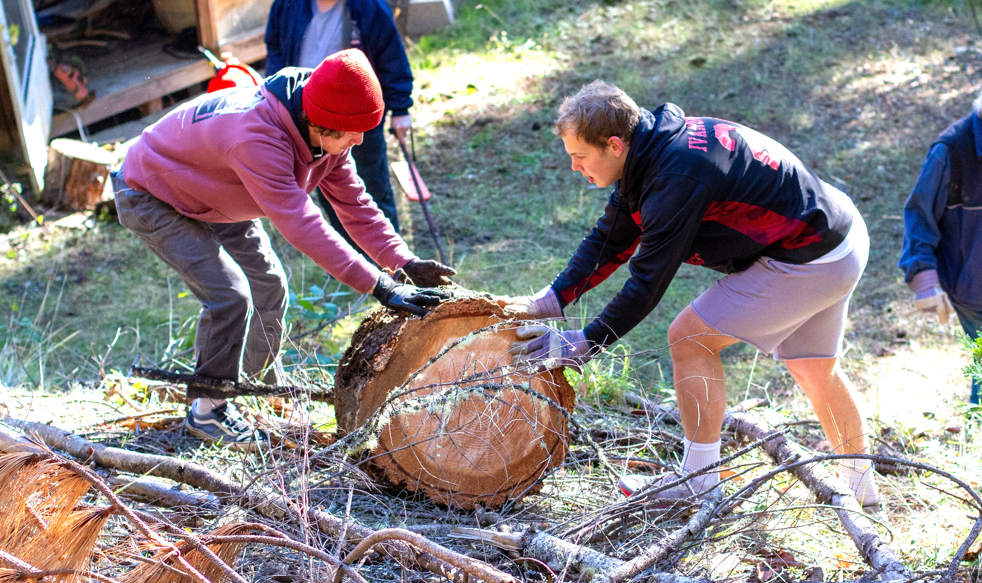

Mission Trips
A part of MAA’s mission is to provide opportunities for students to discover the joy of service. In harmony with this goal, Spring Break has been lengthened to provide opportunities for students to experience mission trips. Students should obtain Ad Council approval before making irreversible plans for trips that are not sponsored by MAA and that require absence from school

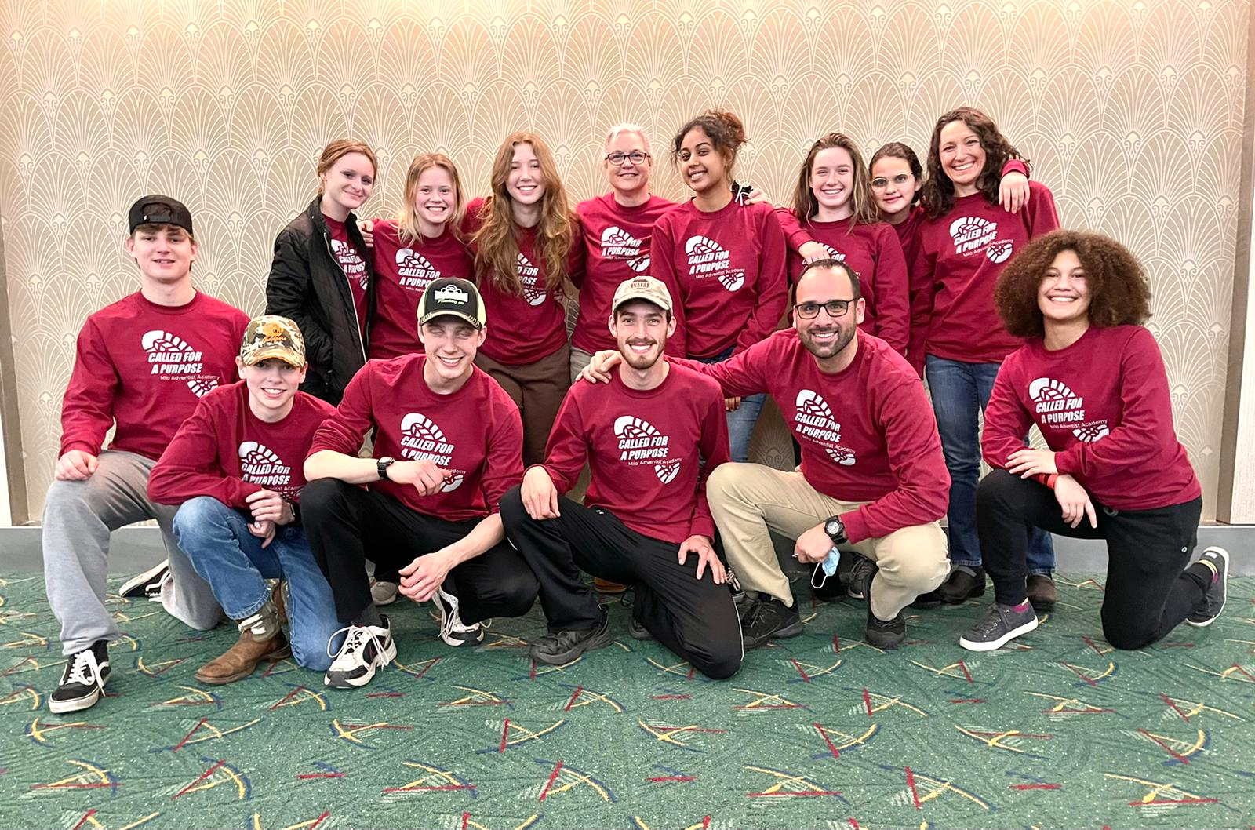
Colorado Mission Trip, 2022

Campus Organizations
Faculty sponsors are assigned to all organizations and clubs. Each of these organizations is to be conducted within the framework of the school’s standards and regulations.
The treasurer of each organization, in cooperation with the sponsors and the school business office, is to keep written accounts of all the funds for the organization. All funds must be received, kept, and disbursed from the business office.
No student association, class, or club meeting has any official status unless at least one of the officially appointed sponsors is present at the meeting.

Student Association (need to develop the constitution)
All students, by virtue of their enrollment, together with all staff members, are automatically members of the SA. This association is the general organization of the student body and is responsible for social and cultural activities.
The Student Association is responsible for weekly SA meetings and special programs throughout the year including:

- Handshake & Watermelon Feed
- Spirit Week
- SA Picnic
- SA Banquet
- Harvest Party
- Christmas Party
- SA Track & Field Day/Milo Mudder

Senate
The Student Senate is the representative body for the Student Association of Milo Adventist Academy. Its responsibility is to carry on the business activity of the SA and to provide a forum for student concerns so that there will be time at regular meetings for cultural, social, and religious programs.

Music Groups
Milo Adventist Academy offers music groups suited to a variety of musical interests. Groups present programs for various church, civic, and school activities. Students are encouraged to plan to be a part of the group for the entire year.

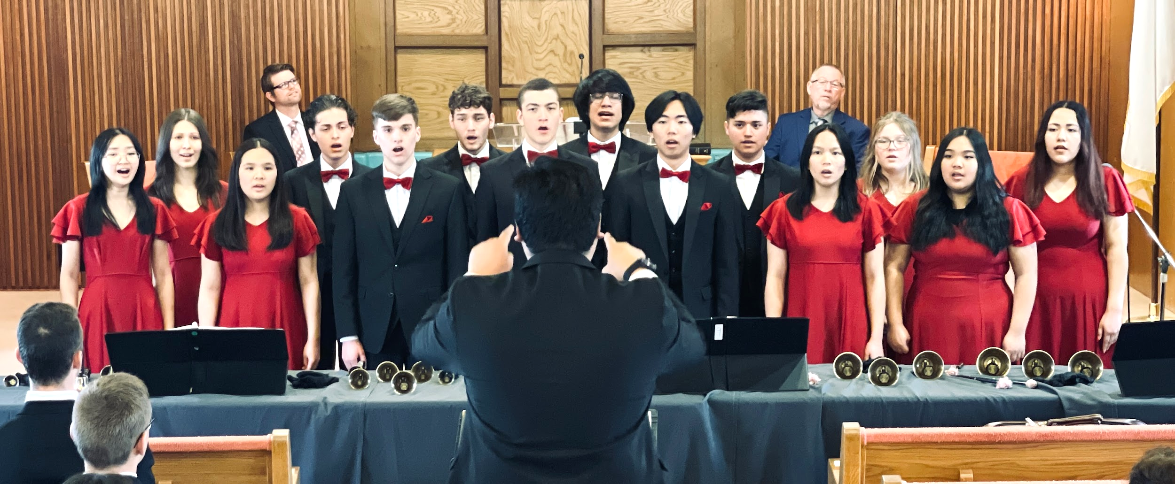

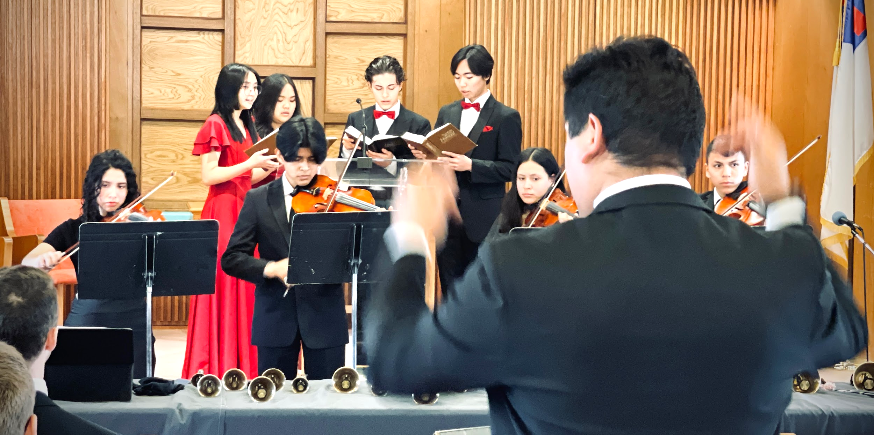

Trillium
The yearbook is published annually in May. Students with an interest in gaining experience in teamwork, project management, photography, and desktop publishing may apply to join the yearbook staff. Students are encouraged to plan to be on the staff for the entire year.

Girls’ Club
The purpose of this club is to promote friendliness, culture, spiritual development, and social enrichment among the young women of Milo Adventist Academy. All female students are members. In addition to their Sunday evening meetings, members of this organization also organize events including:
Fall: Banquet in odd-numbered years
Open House in even-numbered years
Spring: Family brunch
Family Weekend programming

Boys’ Club
All young men enrolled in Milo Adventist Academy belong to this organization. Their objective is to work together to build Christian character. The club provides many cultural, educational, and recreational activities in addition to Sunday evening meetings and organizes events including:
Fall: Banquet in alternating years
Open House in alternating years
Spring: Family Weekend programming

Class Organizations
All students who meet class standing requirements are automatically members of their appropriate classes. In addition to organizing monthly class meetings for business and social programs, the classes enjoy and help to organize specific events. Sophomore and Junior classes organize during the first quarter. The Freshman class organizes at the beginning of the second quarter. Juniors will decide their senior-year class officers during their last quarter of their junior year.
Aside from the big events listed on the table below, class officers will also need to organize various class vespers (only for their own class) programs, chapel, and monthly weekend cafeteria clean up.

Senior Class | Junior Class | Sophomore Class | Freshman Class
Wild and Wacky Games | Wild and Wacky Games | Wild and Wacky Games | Wild and Wacky Games
Harvest Party | Harvest Party | Harvest Party | Harvest Party
Senior Recognition | Jr/Sr Banquet | Sophomore Activity Day | Freshman Activity Day
Track and Field Day | Graduation Weekend
Class Trip
Graduation Weekend

Goals
- To increase the number of students who gain leadership experience.
- To enable students to perform in their responsibilities more effectively.
- To guard against students’ lives becoming unbalanced to the detriment of their health.
- To more effectively teach time management.

Eligibility for Student Office
Sponsors of student organizations will allow only those students with confirmed eligibility to be on the ballot for election to office. Students who wish to run for office establish their eligibility by bringing a completed campaign petition to the Registrar, whose signature will confirm their eligibility. It is their responsibility to return this completed petition to the sponsor by the filing deadline. Campaign petitions are available from the sponsors of each student organization and from the Registrar.
Each student may carry no more than one major responsibility, one major and one minor responsibility, or two minor responsibilities during any one school year.

Major responsibilities
- Junior/Senior class President
- Junior/Senior Executive Vice President
- Junior/Senior Vice Presidents
- Student Association President
- Student Association Vice Presidents

Minor responsibilities
- Freshman/Sophomore class officers
- Boys’/Girls’ Club Presidents
- Varsity/Junior Varsity player or manager
- All other student organization offices

Eligibility
Major offices
Have and maintain:
- Minimum GPA of 3.0
- No F’s
- Minimum attendance grade of C
- Enough credits for class placement
- Appropriate citizenship grade
Minor offices
Have and maintain:
- Minimum GPA of 2.5
- No F’s
- Minimum attendance grade of C
- Enough credits for class placement
- Appropriate citizenship grade
Minimum GPA is for the most recently completed semester grading period and any subsequent quarter grade. Failure to maintain the above eligibility conditions will result in loss of office for the remainder of the school year.

Milo Forum
Feedback plays a crucial role in the continuous improvement culture Milo wants to have. It helps us adopt new knowledge sooner and avoid repetitive mistakes. Milo Forum is designed to formally receive feedback from student leadership in the spirit of making Milo a better place.

Milo Forum is a meeting where student leaders get together with the school leadership team to discuss opportunities for improvement, as well as communicate new initiatives coming up. This forum takes place twice a year during Campus and Neighbor Days. If non-leader students have any issues that need to be brought to this forum, they should contact their class senator.

Campus Policies

All groups of people need operating guidelines to help them work together harmoniously. These guidelines, called protocol, reduce stress and improve communication by providing standardized ways of doing things. This section describes Milo protocol for a variety of needs.

Campus Safety
Safety for students and staff as well as family, volunteers, and visitors is a priority at Milo Adventist Academy. Adventist Risk Management, the school’s liability insurer, provides guidelines for all our churches and schools that are our standard on campus property.

The following points are long-standing Milo policies that help ensure accident free work and recreation by adults and youth alike.

- When driving on campus, maintain a 15 MPH speed limit. This applies to all vehicles.
- Only tested student drivers may operate vehicles and equipment (including golf carts and UTVs– utility task vehicles). This will be based on supervisors’ request. Students may only drive non-road licensed school vehicles. Students may only drive when requested to by their supervisor for specific work-related tasks during their work shift. Testing will be conducted by an appointed school safety tester. Possession of a driver’s permit or license is not an automatic pass.Driving privileges may be suspended if abuse of privileges is observed.
- Riding in the back of pickups on campus is permitted only if sitting on the bottom of the bed, not rails, and driven by a staff member.
- Riding in a trailer is only permitted if it follows Adventist Risk hayride guidelines.
- Helmets are required for all ages on all campus property for wheeled travel and horseback riding including skates, skateboards, scooters, bikes, unicycles, Segway’s and similar, motorcycles, quads & three wheelers, etc. This does not include golf carts and UTVs. A helmet certified for the specific use is required.
- “No wheels on the oval.” No wheeled-travel is allowed on the oval sidewalk with the exception of campus maintenance department or temporary staff work.
- Skating or skateboarding down the paved hill is not permitted.
- Proper safety training is required for use of all power equipment. Ask your supervisor.
- Proper Personal Protective Equipment (PPE) must be worn when using tools and equipment or in designated spaces. A common example would be eye and ear protection when using a string trimmer. Please ask your supervisor.
- Students swimming must be accompanied by a staff member and an appropriate number of certified lifeguards.
- Hiking is encouraged, but be observant when hiking and aware of poison oak, hunting season, livestock, electric fences, etc. If you pass through a gate please ensure you leave it in the same position you found it. Communicating with your Dean is required before leaving.
- No flames are permitted in dorms or school buildings (i.e. candles, incense, lighters, etc.)

Home Leaves Policy
Home leaves are extra long weekends planned to allow students to go home every four to five weeks throughout the school year. They are intended to provide time for medical appointments, a change of pace, and time with family.

Students are expected to leave campus during all scheduled home leaves and vacations, unless they have made special arrangements to work on campus. Dorms are closed during home leaves.

It is important not to miss the school days immediately preceding a home leave, both because attendance in class is essential for learning and good grades, and because the day just before home leave may be the last day of the quarter, and tests will normally be scheduled for that day. Class work or tests missed because a student leaves early for home leave cannot always be made up.

Scheduled home leaves officially begin at 12:30 PM on the scheduled home leave day, and end at 9:00 PM on Sunday. The one exception being Christmas Break which officially begins at the conclusion of the Christmas Music Program. If you will be returning earlier than 5:00 PM or later than 9:00 PM, you must make advance arrangements with the dean. Meal services are not available until breakfast on the first day of classes.

Arranging an Overnight Leave
Any time you wish to leave campus for the weekend or for overnight, and you will not be missing work or classes, arrangements must be made with your dean prior to leaving campus.

- Complete a Campus Leave Request.
- Verify with the Dean that you have received all necessary permissions and your request is approved.

Students will not be granted overnight leaves on the Friday of the Week of Prayer or on the Saturday night before a Sunday when classes meet. If you expect to go to a home other than your own, permission from your parents and an invitation from the family you wish to visit must be submitted to the Head Dean in writing.

You may not leave campus with anyone without parental permission. If the driver is under 21 years of age, the Head Dean must have parental permission for all trips, including weekend leaves.

Leaves for weekends begin after your last class and work appointments Friday. You are expected to be back by 9:00 P.M. the Sunday before classes. Arrangements must be made with the Head Dean prior to leaving. If something causes you to be later than 9:00 PM, you must call the Dean on Duty. Failure to do so will result in Discipline Committee action.

Once you return to campus from a weekend off campus, your leave is officially over, and you may not leave again unless you check out again with the Head Dean.

Milo and the people here are
doing a great job!

CURRENT STUDENT (CLASS OF ‘24)

Arranging to Leave Campus (if you miss class)
Ad Council forms are the paperwork that you will complete in order to make arrangements to be off campus for overnight or weekend leave or for any other occasion which will cause you to miss work or classes.
The Ad Council form is available from the Administrative Assistant’s office. You will need to:
- Explain your reason for leaving campus.
- Give your work supervisor the name of the person who has agreed to substitute for you at work, and obtain the supervisor’s signature.
- Ask each of the teachers whose classes you will be missing to sign the form.
- Have your dean sign the form.
- Deliver the form to the Administrative Assistant before the Ad Council meets that week.

If your teachers and work supervisor have any reasons why they feel you should not go, they will note these on the form. Their signature is not an approval unless they note that beside it.

Visitor Policy
We welcome you to visit Milo campus. Upon arriving on campus, guests should check in with the administrative secretary in the administration building. After school hours, Milo guests should check in with the admin on duty, who will notify the appropriate dean on duty of their arrival. The administrative secretary or dean will issue each guest a guest badge identifying that person as a guest on our campus. If a guest wishes to participate in a specific school activity—meals, recreation, worship, etc.—he/she should request permission from the staff member responsible for that activity. Visitors on campus or attending school functions must abide by the rules of MAA. Staff reserves the right to ask visitors to leave during any activity. Some school activities, such as banquets, are limited to enrolled students.

A student may request permission to have a visitor by submitting a request to the Ad Council. Ad Council requests should be turned in one week in advance.

Guests can be given wifi access when requested from the Administrative Assistant’s Office, or from the respective Dean when they are visiting overnight in a dorm guest room.

Dormitories are the living quarters of our young men and women. Members of the opposite gender are welcome on the first floor only, unless visiting their own child. All visitors must check in with the dean on duty prior to going above the first floor.

Visitors are expected to reserve lodging in advance (Check in with the business office for current rates to stay in a room and pay for meals) in a same-gender dorm and to make arrangements for their meals. Only same-gender parents or siblings are allowed to spend the night in a resident’s room unless deans indicate otherwise for special weekends. Exceptions must be cleared by the Ad Council with parent permission.

Search and Seizure Policy
The individual right of privacy is balanced by the school’s responsibility to protect the health, safety, and welfare of all students and school employees.
The school reserves the right to search student dormitory rooms, lockers, desks, vehicles, and personal belongings for objects or materials deemed noncompliant with the school’s rules and regulations and/or which threaten the safety of the students and staff.

Trip & Tour Policy
To participate in any off-campus school tours, a student must be in regular attendance, in good academic standing as defined under “Academic Standing” in the Intellectual Development section, and have an attendance grade of at least a C. Students who do not belong to the group are not allowed to go on the trip.
For the duration of the trip, students may not ride in any vehicle other than that of their own parents or school-provided transportation.
Exceptions
- Students are covered by insurance to ride with host families to their homes and back to the destination point.
- Students who wish to take their own cars for a specific reason must have permission from the Ad Council. No other student may ride with them.
Students who are a part of a touring group are subject to the policies and standards of Milo Adventist Academy. Students who violate the policies and
standards of the academy or violate the announced rules of a particular touring group will be referred to the Discipline Committee for disciplinary action; the student may also be sent back to either the academy or the student’s home on the most convenient form of transportation, at the expense of the student or the parent/guardian(s) of the student.
Disruption of the tour by students will not be tolerated; thus, the tour will continue, and the student will be disassociated from the tour. Such students may lose the privilege of being in a particular touring group.

Accident Policy
It is the aim of the academy to do everything possible to prevent accidents, but with a large group of students some may occur. It is the student’s responsibility to report all accidents to their work supervisor for work-related accidents or to the administrative secretary if the accident occurred somewhere other than at work. If not reported, insurance may be denied, and the expense will become the responsibility of the parent. Accident report forms are available from the administrative secretary and from the deans.

Village Students
Village (day) students have made the same commitment as dormitory students and should follow the same guidelines.

Each student, whether dormitory or village, will be given a copy of the student handbook and the dorm handbook for his/her gender at the beginning of the school year. Village students are requested to attend the dorm worship at the beginning of the school year when guidelines are explained.

Vehicle Policy
Students may be given permission to park their vehicles* on campus under the following conditions. Failure to fulfill any of the conditions outlined will automatically cancel the privilege of having a vehicle on campus.
- Register the vehicle within forty-eight hours of arrival on campus.
- Use your vehicle only for transportation to and from your home during any approved overnight or weekend leave. Student vehicles may not be used for school-sponsored outings/activities.
- No other student drives the vehicle.
- Other students are transported in the vehicle only when permission is on file with the deans from both sets of parents.
- When not in use, the vehicle is parked in its assigned parking space at all times. Violations will result in a fine.
- Proof of liability insurance for the vehicle is on file with school administration.
- The student and his/her parent(s)/guardian(s) have signed the Vehicle Parking Permit contract.
- Students must recognize that MAA cannot take responsibility for vehicles parked on campus.
- Students recognize that MAA’s accident insurance does not cover injuries sustained while riding a two, three, or four-wheeled ATV motor vehicle.

*Dormitory students may not bring motorcycles or two, three, or four-wheeled ATV’s on campus.

Non-dorm students riding motorcycles to and from school are not covered by MAA’s accident insurance. Also, they may not transport fellow MAA students as passengers on their two, three, or four-wheeled motorcycles or ATV’s.
Village students
Village (day) students have made the same commitment as dormitory students and should follow the same guidelines.

Each student, whether dormitory or village, will be given a copy of the student handbook and the dorm handbook for his/her gender at the beginning of the school year. Village students are requested to attend the dorm worship at the beginning of the school year when guidelines are explained.

Dress Code
The way we dress reveals something about how we view ourselves and others. MAA dress standards apply on campus and on all school-sponsored tours and outings for all students, village and dorm.
At MAA we seek to create an environment where . . .
- students are encouraged to focus on a personal friendship with Jesus, on academic excellence, and on wholesome social relationships.
- personal value is based on what Jesus is doing in us rather than on outward display.

Specific Dress Guidelines
- Shorts must have an inseam extending at least halfway to the knee.
- Skirt length must extend to the top of the knee. Slits should be no longer than 1/4 of the skirt length from the hem. Leggings do not increase the length of your skirt.
- Pants, shorts, and skirts must be hemmed.
- No torn or ragged clothing or clothing with holes
- Clothing must not allow underclothing or midriffs to be visible when arms are raised. Necklines must be modest and not low cut.
- Sleeveless clothing must be snug fitting under the arm and have mid-shoulder straps at least two inches wide. Straps less than two inches wide must be covered by solid material.
- Hats or head coverings are not to be worn in the church, admin and music buildings, cafeteria, and student center.
- No tight clothing
- No sleepwear or slippers outside the dormitories.
- No jewelry or jewelry related items (will be confiscated).
- Natural, inconspicuous, neutral tone nail polish is acceptable.
- Hair is to be kept neat, clean, and of natural color. Extreme hairstyles are not appropriate at any time.
- Body art or marking is not acceptable.
- Women: dress pants may be worn. (No cords, denim, or khaki fabrics)

Dress Categories
Campus Dress Principles and Specific Dress Guidelines are the general rule. Additional dress categories and specifications follow.

Work Dress
Applies while performing assigned work. Exceptions are at the discretion of the work supervisor.
Sabbath Sanctuary Dress
Sabbath dress applies for Vespers, Sabbath School, and Church.
Men
- Dress pants. No jeans of any color, joggers, or cargo style pants.
- Dress shirts are full-buttoned short or long sleeved and do not include T‑shirts, polo/golf shirts, or sweatshirts. Dress shirt tails are to be tucked in.
Women
- Dresses OR with skirts or dress pants (no khaki, leather or denim) with nice sweater or blouse (no T-shirts)
- No sweatshirt or denim jackets may be worn for vespers or church dress.
- No leggings (Leggings are allowed under skirts and dresses)

Sports Dress
Sports dress applies to participants in PE or sporting activities.
- Sports bras may be worn with a tank top having snug-fitting under arms and mid-shoulder straps at least two inches wide. Three finger widths?
- Swimwear
- Women– modest one-piece suits; no tankinis (unless the midriff stays covered when arms are raised?) tankinis are some of the more modest swimsuits.
- Men– loose-fitting swim trunks/shorts.
- Shorts must have an inseam extending at least halfway to the knee. Is this for class? (credit card length) SA activities? (swim shorts okay) Sports? (volleyball shorts)

Banquet Clothing
Banquet dress should meet the specific dress guidelines. Deans must approve all banquet attire for both village and dorm students prior to the banquet.

Milo invokes growth and learning in a safe and nurturing environment.

CURRENT STUDENT (CLASS OF ‘25)

Computers and Network
Milo Adventist Academy is pleased to offer access to computer networks, including the internet, provided students honor the MAA acceptable use policy. Juniors and seniors may bring their own computers and are subject to the same Acceptable Use Policy. Violation of the policy may result in suspension or loss of network access privileges, as well as other consequences as determined by the Discipline Committee. Freshman and Sophomore will be provided a school-managed computer in their dorm room. They may also apply for an exception to this rule.

Each student will be given a personal account on the network and a Google account, which may be used to store homework files, access the internet, and classroom assignments. Computer workstations are available in labs in the administration building, technology building, and dormitories. Students will be expected to access the internet only through the campus network.

Network Acceptable Use
The entire policy is in the enrollment packet. We ask that you read it and that student and parent/guardian sign to indicate a commitment to keeping the letter and spirit of the policy. An abbreviated version appears below.

Responsibilities
All use of the system must be consistent with the mission of MAA.

Access to the System
No person shall have access to the system without having received appropriate training during orientation, including a clear understanding of the MAA Acceptable Use Policy. A person who violates this policy will be considered to have terminated his/her agreement and will lose network use privileges.

MAA Limitation of Liability and Indemnification
MAA makes no warranties with regard to the system. Users will indemnify and hold MAA harmless from any losses sustained as the result of any misuse of the system by the user.

Due Process
MAA will cooperate fully with local, state, or federal officials in any investigation concerning to or relating to any illegal activities conducted through the system. If a student has violated the MAA Acceptable Use Policy, he/she will go through the usual Milo discipline process.

Parental Notification and Responsibility
This policy contains restrictions on accessing inappropriate material, and student use will be supervised. It is not practically possible for MAA to monitor and enforce a wide range of social values in student use of the Internet. The school encourages parents to specify to their child(ren) what material is and is not acceptable for their child(ren) to access through the MAA system.

Unacceptable Uses
- Personal Safety—Users will not post personal contact information about themselves or other people to an insecure site. Students will promptly disclose to a staff member any inappropriate message they may receive.
- Illegal Activities—Users will not use the MAA system to do anything illegal including: going beyond their authorized access, using another person’s account, accessing another person’s files, attempting to disrupt the computer system performance or any other illegal act. Students will not plagiarize or copy copyrighted material from the internet.
- System Security—Users are responsible for the use of their individual accounts and should never provide their password to another person.
- Inappropriate Language—Users will follow the Milo mission statement in their communications with others. No obscene, disrespectful or discriminatory attacks.
- Respect for Privacy—Users will not publicize communication from or private information about another person.
- Respecting Resource Limits—Users will respect the limitations of the MAA system by remembering that the network is prioritized for educational and professional development activities. Users will not download large files unless absolutely necessary and at a time when the system is not being heavily used. Users will not spam.
- Inappropriate access to material—Users will not use the MAA system to access material that is profane or obscene, that is pornographic, that advocates illegal or dangerous acts, that advocates violence or discrimination towards other people, or that advocates any belief or behavior contrary to Christian principles. Students who run across such material should immediately notify an MAA staff member.
- VPN– Use of VPN shall not be allowed.
- New Networks– The creation of hotspots or extra networks are not allowed.

Games
Includes video games, computer games, hand-held games, board games, etc.

Games not allowed
- Any game with the rating of M (Mature. Age 17+), AO (Adults only. Age 18+), or RP (Rating Pending). No exceptions.
- Games that fall into these categories: Emulators, Fighting, Role-playing, and Shooters. There may be exceptions which will be reviewed by the Tech Committee on a case-by-case basis.

If the world deems a game inappropriate for persons under the age of 17, what does that say about the values it is teaching in that game?
- Emulators– they are largely used for illegally playing games that you do not own.
- Fighting– a game in this category is a game whose sole purpose is to harm or injure your opponent with/without weapons.
- Fantasy/Role-playing– games within this category are those where you control 1 or more characters through an environment (imagined or realistic) to usually defeat some type of threat. The problem with most of these games are heavily based on Dungeons & Dragons and/or use sorcery (magic).
- Shooters– the only goal in games of this type is to kill (someone/something) or be killed.

Petition for approval
- Write a letter to the Tech Committee stating why you feel the game should be allowed.
- Provide access to the Game committee to play/test the game in question.

I like everything here just the way it is.

CURRENT STUDENT (CLASS OF ‘25)

Dorm Policies

Residence Hall Registration
Before you receive your assigned room, you must complete the forms in the Mitchell/Emery Hall Registration Packet. When all forms have been completed, a room assignment will be issued. Returning students must also fill out these forms to re-register. Once the registration forms are completed you will receive a Check-In form for your assigned room, completely fill out this form to record the current state of the room including any damages, failure to do so may result in loss of room deposit at Check-Out. Once the Check-In form has been completed you will receive a room key. The electronic keys for the front doors can be obtained from the Administrative Office.

Dorm Room Assignments
The dean uses citizenship grades to make room assignments at the end of the summer.

Each dorm room contains a bunk bed, 2 built-in closets, 2 built-in dressers, a sink with a vanity mirror, desk(s) and chair(s). Each room has a window, for which the blinds are furnished. All decorations are subject to approval by the dean. In decorating, keep in mind that Milo is a Christian school and this should be reflected in room decor. A resident rents only half of the room meaning that at any time a roommate could be assigned to them. All furniture must be kept in the same room. Any furniture additions/subtractions must be approved by the dean before it is moved in/out. The resident could be subject to fines for unauthorized removal of furniture from rooms.

It is required that all dorm décor be within the guidelines of Christian appearance. The resident will be asked to remove any posters or other paraphernalia deemed inappropriate. If the items are not immediately removed, they will be confiscated and given to the residents’ parents on their next visit. Do not use tape to hang decorations. Residents will pay for damage caused by hanging décor with tape or other unapproved substances/means. Poster putty or 3M command strips are strongly recommended.

Room Changes
Room change will be considered after the first two weeks of the semester have passed. Before a request is granted, the dean may require you to meet with them and your roommate. If you are an underclassmen you will not be given your own room and should keep this in mind before requesting a room change. Room changes occur only by approval of the Head Dean.

Check-Out Form
When leaving or changing rooms, it is important to follow the check-out procedure:
- Pick up a Check-out form from the Dean/RA.
- Thoroughly clean your room per the check out list.
- Have the dean check the room and sign your form.
- Return or exchange your room key with the dean. Turn in your prox entry fob during final check out.
Any necessary repairs/cleaning or failure to follow check out procedures could result in extra charges and or fines.

Mail
Outgoing mail should be taken to the Business Office. Incoming mail is picked up by the dean from the Business Office in the afternoons. Once the mail arrives in the dorm, it is placed in the dean’s office, dorm mailboxes, or rooms. The Deans reserve the right to open any packages with or without the student present.

Keys
A key to your room/lock drawer is issued to you when you receive your Check-in/Check-out Form. Your key is your responsibility. We are not responsible for missing or lost keys. Upon move out, if a key/prox entry fob is not returned, there is a non-refundable $25 lost key charge. If locked out of your room, you may be charged a $1.00 fee by the Dean on Duty or Resident Assistant to unlock your room for you. Keys left in locks will be confiscated and a fine may be assessed. Keep your door locked; the school is not responsible for missing articles and valuables.
Possession of unauthorized keys will result in immediate disciplinary action which may include suspension or dismissal.

Confiscations and Fines Policy
Having any of the items in the “Not to Bring” section or other items deemed inappropriate by the dean will result in the items being confiscated. Certain confiscated items will not be returned or only returned to parents. Some items carry a cash fine. If fines are applicable, they must be paid before the item is returned. Residents have until the end of the semester to pay their fine. At the end of the semester, items not paid for become property of the residence hall. Final exams may be withheld until the fine has been paid. Repeat offenders may be referred to the Discipline Committee.

What NOT to Bring
- Fireworks
- Bladed Weapons/Knife with a blade longer than the width of your palm
- Firearms/Projectile Weapons (airsoft and pellet included)
- Halogen Lamps
- Hot Plates
- Microwaves
- Air Conditioning Units
- Video Games with a M or Higher Rating
- TV or Video Game Console Devices or External Media Players
- Movies/Show higher than a PG rating
- Any Media/Print/Games that do not support/promote SDA attitudes or principles
- Incense/Candles with a wick/lighters/Matches
- Cigarettes/E-Cigarettes/Vaping pens or devices/drug paraphernalia/illicit or illegal drugs
- Caffeinated products

Computers
There are dorm computers and a printer available for residents to use in each dormitory. Students using the computers for homework will have priority over those using them for recreational purposes. Eating at the computer desks is prohibited because it can damage the equipment.

Telephones
All residents are provided with a phone in their room. Please remember that having a phone is a privilege. Students should refrain from using their phones during study hall and after lights out. Use of phones after lights out may result in loss of phone and/or privileges. The extension for each dorm room is 4+ the room number for girls (ex. 4123) and 2+ the room number for boys (ex. 2123).

Voicemail Instructions
For voicemail instructions see student resources on the student drive.

Security Cameras
There are security cameras in Mitchell/Emery Hall on all floors and lobby areas. These cameras are used to ensure the safety and security of students. The deans will monitor cameras as needed. Tampering, disabling, or damaging security equipment will result in disciplinary action and fines being levied.

Citizenship Tiers
An integral part of Milo’s Residence Hall program is to teach and encourage students to have self-discipline and to embrace responsibility. Such students that show such ability can be eligible for additional privileges on a quarterly basis. See the Dorm Manual for more details.

Study Hall
All residential students are required to be in their respective dormitory by 7:30pm Sunday-Thursday for nightly worship and study hall. Worship begins promptly at 7:30pm and study hall follows at 8:00pm and generally ends at 10:0pm with lights out. Please see your respective Dorm Manual for additional details. During this time a quiet study environment is maintained.

Resident Assistants (RA) are employed by the Dean to help maintain accurate records of student activities during study halls and take attendance to required events such as Dorm Worship, Vespers, Sabbath School, Church, Sunset Meditations, and other such situations that are designated by the Dean.

During Study Hall each resident is expected to communicate with their RA of their whereabouts unless they are in their own room; additionally RAs are empowered by the Deans to encourage and support students with good study habits and prioritization. For more detailed information on Study Hall please refer to your Dorm Manual.

Entering and Exiting the Dorm
Mitchell & Emery Halls are open from 6:00 AM to 10:00 PM on weekdays. All residents must be accounted for at every check including worship, night checks, and any other time that the dean on duty has specified for residents to be in the dorm. Residents are NOT to leave the dorm in the morning before 6:00 AM or after 10:00 PM. Any exceptions must be approved by the dean in advance. Any resident that is found out of the dorm without pre-arranging it before 6:00 AM will be subject to disciplinary action.

The oval is closed until classes begin. Students are expected to remain in the dormitory before classes begin unless going to the cafeteria or to a supervised activity such as work or athletics practice. Anyone out of the residence hall without permission before 6:00 AM or after 7:30 PM curfew will be subject to disciplinary action. Residents involved may be subject to suspension and/or dismissal from school.

Appliances
Refrigerators are the only appliances allowed in dorm rooms. Please do not bring microwaves or open element items, as these are fire hazards. Cooking appliances will be available for use in the dorm kitchens. Residents need to monitor their food cooking in the kitchen.

Fire Safety
Fire safety equipment should not be tampered with. Fire safety equipment includes fire extinguishers, smoke detectors, fire alarms, and fire exit doors. Any misuse of these safety items will result in a fine and possible action from legal authorities and MAA.

Fire Alarms & Drills
The residence hall will have a fire drill each month. The Head Deans will discuss the procedure for Fire Drills in Dorm Orientation.

Dean on Duty
There is always a Dean on Duty 24 hours a day whenever school is in session and dorm students are present on campus. They are there to assist the residents with any needs that arise even in the middle of the night; if you have an emergent need DO NOT hesitate to call the Dean on Duty. The Girls’ Dean on Duty can be reached at: extension 4151; the Boys’ Dean on Duty at: extension 2151.

Other Safety Regulations
- The only approved extension cord to be used is a power strip and must be U.L. approved with a rating of 20 amps.
- All power strips must have a manual and automatic resetting circuit breaker. Power strips may not be daisy chained (one plugged into another to make a longer cord).
- Open coil or open wire appliances such as toasters, toaster oven, open type grills are not allowed.
- Candles or tea lights, any open type of flame using liquid fuels are not allowed in student rooms.
- Electrical irons or curling irons/flat irons should not be plugged in or left on when unattended.
- Items deemed to be unsafe will be confiscated.
- Fines may be applied for certain items.

Restraints and Involuntary Seclusion
Oregon law limits child care agency’s use of physical restraints and the practice of involuntary seclusion. They are also required by Oregon Administrative Rule (OAR) 419-400-0180(13)(E) to publish quarterly reports of all use events. Milo Adventist Academy does not practice usage of restraints or involuntary seclusion of children in their care. We are, however, still required to provide quarterly notification identifying this nonuse. These quarterly reports may be found on our website at https://miloadventistacademy.com/parents-and-students/ under the tab DHS Reports.

It is Milo’s intent and ambition that students and parents know their rights and have full confidence in the event that they need to report
concerns or suspicion of inappropriate use of restraints or involuntary seclusion.
- Reports may be shared with a member of the administrative team, including the school secretary, or any other trusted staff member.
- Students and parents need to know that all reports are confidential and neither will experience any form of retaliation in response to reporting suspected inappropriate use of restraints or involuntary seclusion.
- Students and parents may always make a report directly to any of the following Oregon State support entities:
  - Child Abuse Hotline (855) 503-7233
  - DHS-Children’s Care Licensing
Mary Torres (503) 798-5300
mary.torres@odhsoha.oregon.gov
  - Disability Rights Oregon (503) 243-2081

Selling and Soliciting
These activities are prohibited in both Mitchell and Emery Halls. Please refrain from operating any dorm room stores.

Windows
The windows in the dorm must not be used as an exit. Students who are found with missing screens will be fined each time the screen is found absent from the window. Those who use the windows as an exit will also be assessed a fine for each occurrence and may face disciplinary action. All body parts must remain inside the windows of the dorms at all times.

Pets
Small lizards and fish are the only pets acceptable in the dorms and must be contained in 5-gallon tanks or smaller. Failure to care for, or unpleasant odors due to lack of tank maintenance will result in the pet being removed and further pet privileges being revoked. No snakes or arachnids please.

Overnight Visitors
Visitors are only allowed to stay overnight in the dorm on special weekends (i.e., Family Weekend, Alumni Weekend, Graduation) and with prior notice. Any visitors wishing to stay must receive the permission of the Head Dean at least 24 hours in advance and may also be charged a fee for the stay.

Financial Information

It is the purpose of the Milo Academy Operating Board to keep the school charges as low as is consistent with good business management. Owing to the uncertainty of economic conditions, the Board reserves the right to revise the published rates without notice.

Annual Financial Supplement
See the annual financial supplement for the current school year for current financial information and amounts.
Information included in the supplement:
- Tuition and Fees
- Entrance Fees
- Current year payment schedule
- Guest meal prices
- Horse program plan fees
- Initial Payment Discounts
- Home Leave bus fees
- Transportation fees
- Varsity Program Fees
- Prices for guest accommodations

Payments
Statements are mailed on or about the fifth of each month. Payment is due by the twenty-fifth of each month to avoid late fees. All checks, drafts, or money orders should be made payable to Milo Adventist Academy in US funds and sent directly to the school. These charges, divided into ten equal billings, will show on your statements.

Entrance Fee
A nonrefundable fee (see the financial supplement) is charged to each student. This fee covers:
Boys/Girls Club Outreach
Class Dues Registration Fee
Counseling/Testing Student Association
Entertainment Student Accident Insurance*
Intramural Fee Technology
Library Yearbook/Mugbook
*The school provides a secondary accident insurance policy for all enrolled students. Complete information, including coverage and exclusions, will be sent upon request. It is the student’s responsibility to report any accident to the administrative secretary within 24 hours. See further information on accident reporting procedures on page 9 of this handbook.

Cash Items
May not be charged to student accounts. Exceptions must be approved by the VP for Finance.
- Home leave bus fee
- Art supplies
- School pictures
- Choir and other group outfits
- Graduation expenses
- Varsity fees
- Class, club, and SA shirts
- Replacement room key
- A.P. or standardized tests

Other Fees

Advanced Placement Exam
Students who register for Advanced Placement classes are required to take the exam for that class. The fee for the exam must be paid in cash by the end of March.

Application Fee
A one-time nonrefundable fee is required to process a first-time application for Milo Academy. See the current financial supplement for the amount.

Cafeteria Charges
Dormitory students are charged a flat rate for food service and are encouraged to come to all meals, as there is no refund for missed meals. The flat rate takes into consideration meals not served while students are not on campus due to home leaves and scheduled vacation times.
Village students, parents, and guests may purchase individual meals at the current rate. The meal must be paid for in cash or check at the time of purchase.
Meal tickets may be purchased with cash, check, or credit card from the cafe or business office. You are encouraged to purchase meal tickets in advance for weekends you will be visiting MAA. Tickets are valid the entire school year. Checks should be made payable to Milo Adventist Academy.

Horse Program

A riding release must be signed before a student can ride any horse on Milo’s property or off campus in a horsemanship program sponsored activity. Riding releases can be found on the school’s website.
- Students can bring their own horse to board at Milo.
- Self care $100/month
- Full care $300/month
Email the horse director at horses@miloacademy.org for additional information on student horse boarding. Pricing is subject to change.

Lab Fees
This fee is collected before taking the class to cover supplies and materials needed. These are the following:
- Family Consumer Science
- Folk Art
- Advanced Foods
- Fabric Art
- Drawing
- Pottery Class

Refunds
Students who enter late or are absent for a time, but who make up back work and receive credit will be charged full tuition. A student entering school at an irregular time will be charged from the beginning of the week in which he/she enters. A student leaving school at an irregular time will be charged through the close of the week in which he/she leaves. No rebates are made for vacations.

Textbooks & Supplies
Textbooks, workbooks, lab fees, etc. will be charged on the statement. Textbooks which will be used again may be sold back to the school for half of the purchase price if in good condition.

Transcript Fees
The first transcript issued after graduation is free. See the current financial supplement for the fee for additional transcripts. No transcripts can be issued for students who have an unpaid bill.

Varsity Program Fees
Students who participate in varsity sports are required to pay a fee to cover extra expenses of the program. This fee must be paid in cash at the business office prior to the beginning of the season and may not be applied to the school bill. See the current financial supplement for the fee schedule.

School Pictures Fees
All students will be photographed free of charge for student ID cards and file photos. Those who wish to purchase pictures will make prepayment to the photographer, not to the school, on the day when pictures are taken. Please have checks or cash ready on picture day. Pictures may not be charged to the school bill.

Security Deposit
A security deposit is charged to each dorm student when the room assignment is made and the key is provided. This deposit is refundable if the room is left in good condition and all keys are returned. See the current financial supplement for the fee.

Students Without Health Insurance
If students do not have health insurance, a deposit is required at registration for medical copay, doctor visits, and prescriptions. Parents are responsible for any additional medical costs for their child during the year.

Vehicle Permit Fee
Students must obtain a permit for the privilege of parking a vehicle on campus. Register the vehicle within 48 hours of arrival on campus according to the conditions outlined in the “Vehicle Policy” section of this handbook. An annual nonrefundable fee is required for this vehicle permit. Students must park their vehicle on the center island in the main parking lot to leave very limited space between oval buildings open for visitors. See the current financial supplement for fee

Transportation Fees
Home Leave bus fees are based on a round trip. One way is half the price of a round trip. Cancellations are 50% refundable. Students must sign up 48 hours in advance to be assured a seat. See the current financial supplement for costs and schedules.
Buses stop in Roseburg, Cottage Grove, Springfield/Eugene, Albany, Salem, Gladstone, Portland airport (PDX), Grants Pass, and Medford and Medford airport (MFR). Times are approximate, and locations are subject to change.

Town Trips
Approximate charges based on current fixed rate. See the financial supplement for the current rate. Contact the Administrative secretary to make transportation arrangements.

Please note before making travel arrangements:
- To be transported to an airport and then picked up from the airport at a later date constitutes two trips. A travel discount may be possible if the trip can be made in conjunction with the regularly scheduled home leave bus.
- Transportation to Portland is provided only when a staff member is available to drive. The 500-mile round trip takes approximately nine hours. Please schedule any flights into Medford (MFR).

Student Bank
Students have miscellaneous cash needs from time to time. Students may keep cash in a student bank account for these expenses as they arise. Students are not allowed to make cash withdrawals against their student accounts except in an emergency. Parental authorization must be on file and the student’s account must be current, or no cash will be advanced.

Ways to Pay
Milo Adventist Academy is committed to helping teenagers meet the financial obligations of Christian education. While some families have the financial resources to pay their students’ bills in cash, many others need to take advantage of other means to meet their obligations.

Sources of revenue fall into three categories:

- Cash
- Earnings from the student’s Summer work program
- Financial assistance.

Discount plans are also available to some students. Tuition fees are payable in U.S. dollars. Milo accepts payments made with all credit and debit cards.

Financial Plan Worksheet
All parents/guardians must submit a completed financial worksheet. This will be used to determine your monthly payment amount.

Collection Policy
MAA must collect tuition in a timely way in order to operate. If you believe you will have difficulty meeting this policy, we invite you to apply for student aid by contacting the Vice Principal for Finance. Any exceptions to the policy must be submitted in writing to the Finance Committee of the MAA Board for consideration and approval.
- All account balances from Milo or any other school must be paid or acceptable arrangements made with the VP for Finance before entering the next semester. This applies to both the Fall and Spring Semesters of the school year.
- A financial plan will be developed with the Vice Principal for Finance that will result in a zero balance account by the end of the current school year.
- If a student fails to meet the student labor agreed upon in the financial plan, the parent/guardian will be responsible for the full balance.
- Failure to make a monthly payment will result in a contact from the Finance Committee. For any month in which no money is received on a given account, a late fee of $20 will be added.
- If an account becomes 60 days past due, the Finance Committee will ask for an agreed-upon payment to be received within 10 days, or school services will be suspended to the student.
- Before they may participate in graduation exercises and receive their diplomas, all seniors’ accounts must be paid in full. To allow for timely processing, final payment should be received by May 25.

Discount Plans

Family Discount
Families having more than one student attending at the same time will be given the following annual discount per student on tuition only.
Students/family Dorm Village
2+ 4% 2%
3+ 5% 3%

Initial Payment Discount
Parents desiring to pay the initial payment will receive a discount if paid by July 15. See the current year supplement for specific discounts.

Yearly/Semester Payment Discount
Parents desiring to pay the total yearly fee in advance will be granted a 4% discount. Those desiring to pay half of the yearly fee in advance will receive a 3% discount.

Student Labor
The student Summer work program at MAA allows students to earn a significant portion of their tuition through their own endeavors. Depending on the number of hours worked, students may earn an average of $350 per week to apply to tuition costs.



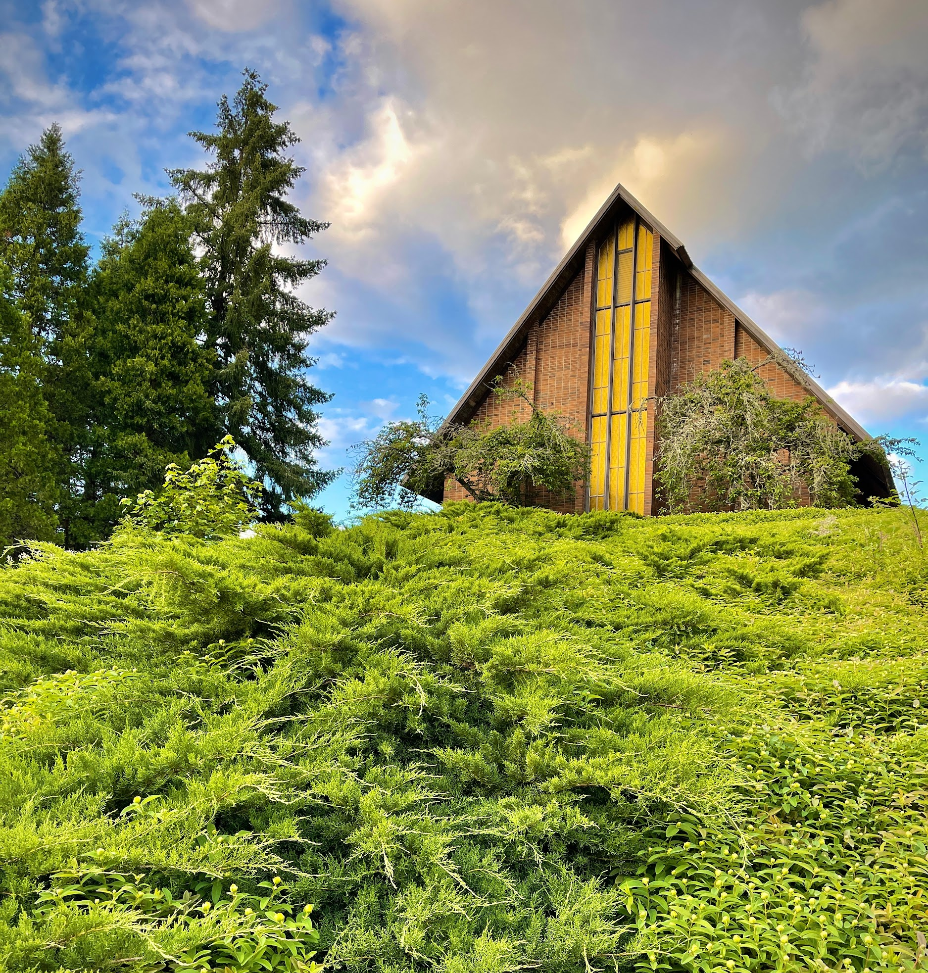

Financial Assistance

NPUC Hispanic Scholarship
Hispanic families in need qualify for the NPUC Hispanic Scholarship Program. Qualified families can receive an annual scholarship. The funding for this scholarship is made up of a three way partnership, church = $200, school = $600, NPUC = $600, for a total of $1400. Applications are available from the Vice Principal for Finance or from our website. To obtain this scholarship, applicants will…
- Fill out the top section of the application for each student.
- Submit the application to the local church for approval and signature of church officials.
- Take the application with the signature of the church official to MAA’s VP for Finance for approval.
- The VP for Finance must receive the church portion and certify that he/she has received it by his/her signature on this application.
- This application must be sent to the NPUC (fax: 360-857-7127) from the school.
- Schools will not send applications until September 15, in order to confirm that the student has enrolled.
- If the applicant does not enroll or continue in the school, MAA is expected to refund the NPUC portion.

Academic Scholarships
Each year several students from Oregon Conference constituency, including Milo juniors currently enrolled, are awarded a $1000 tuition scholarship. To qualify for these, students must give evidence of academic promise as well as a commitment to the values which Milo Academy was established to nurture. Contact the registrar or admissions office for more information on how to apply for this scholarship.

Pathfinder Scholarships
Milo Adventist Academy will be awarding scholarships this year to Oregon Conference Pathfinders. The amount of each scholarship will be between $500 and $1,500 as determined by the scholarship committee and announced at the Pathfinder Fair in May. These funds will be subject to admission approval with half of each scholarship applied to the student’s tuition in November and the second half in March.
Names of current Pathfinders who would welcome the opportunity to attend Milo must be submitted by May 5 and include the following:
- A recommendation letter from your Pathfinder director and one other non-related adult.
- A one-page statement from the student explaining why he/she wants to attend and how it will benefit him/her.
- A list of activities in which the Pathfinder has been involved.
- Submissions must be mailed to business.office@miloacademy.org

Staff at Milo are
understanding, reliable, and kind

CURRENT STUDENT (CLASS OF ‘23)

Index

A-C
Absences 23-25,28
Academic Standing 23,31
Acceleration 21
Accident Reports 13
Accredited by 6
Ad Council
Withdrawal 15
Prearranged Absences 25
Mission Trip 28
Leave, Visitor, Trip & Tour 31
Alcohol 16,18
Application Procedure 9,36,38
Asbestos 7
Attendance Grades 18,26,29,30
Attendance Policy 24,25
ATVs 32
Banquet Clothing 32
Behavior Guidelines 14
(see Social Guidelines)
Boys’ Club 29
Bus Decorum 15
Cafeteria 8,12,14,24,29,35,36
Class Load 20
Class Organization 29
Class Placement 21,23,29
Collection Policy 37
College Preparatory 20
Commitment 4,5,14,31-33,38
Computers 20,22,27,32-34
Correspondence Courses 22
Course Descriptions 20
Course Offerings 21

D-F
Discipline Appeal Process 15
Discipline Categories 18
(see Infraction Levels)
Discipline Policy 14-18
(see Social Discipline)
Discount Plans 37
Dress Guidelines 32
Dropping Classes 22
Drug Testing 16
Eligibility
DFI 23
Student Office 28
Varsity Games 12
Enriched Diploma 21
Entrance Fee 32
Exercise 10
Faculty Family 14,19,24
Financial Assistance 37,38
Financial Information 36
Fines 34,35
Food & Nutrition 12
Four-Year Plan 21
Freedom of Expression 16

G-I
Game Policy 33
General Program 20
Girls’ Club 29
Grade Reports 23
Graduation 20-24
Guest Information 8,23,31,36
Hispanic Scholarship 38
Hotels 8
Home Leave 11,30,36,37
Honor Cords 24
Illness 13
Initial Payment Discount 36,38
Insurance, Accident 13,31,32,36,37
Intellectual Development 5,20
International Students 9,22
Items Not to Bring 34

J-M
Leadership Opportunities 26-29
Mailing Address 8
Medical 13
Minimum Class Load 21
Mission Statement 4
Mission Trips 28
Motorcycles 30,32
Music Groups 25,28

N-P
Network Acceptable Use 33
Non-Discrimination 6
Payments 36
Physical Health Development 12
Picture Fee 37
Prearranged Absences 25

R-T
Recreation Period 12
Rest 12
RVs 8
Sabbath 8,11,32,35
Safety 7,16,27,30,33,35
Search and Seizure 7,31
Security Deposit 37
Senate 28
Sexual Harassment 7,16,17
‘Social’ 14
Social Health Development 14
Social Relationships/Guidelines 14
Spiritual Experience 11
Sports (see Varsity) 12
Sports Dress 32
Student Association 26-29
Student Bank 37
Student Records 20
Tardies 24
Testing 16,21
Textbook Charges 36
Tobacco 16
Town Trips 37
Transcripts 9,21-25,37
Transfer Credit 21
Travel 9,30-37
Trillium 28
Trip & Tour Policy 31
Tuition & Fees 36

V-Y
Varsity Program 12
Varsity Fees 37
Vehicle Policy 30,32
Visitors 13,31,35,37
Vocational Development 26
(see Practical Skills Development)

W-Z
Walks 12
Weekend Leave 30-32
Withdrawal 15-20
Work Policy 26
(see Practical Skills Development)
Worship Services 11,19,24
Yearbook 22,28,36

